Q1. Query all columns for all American cities in the CITY table with populations larger than 100000. The CountryCode for America is USA.

Query:-

select * from city where countrycode = 'USA'and population > 100000;

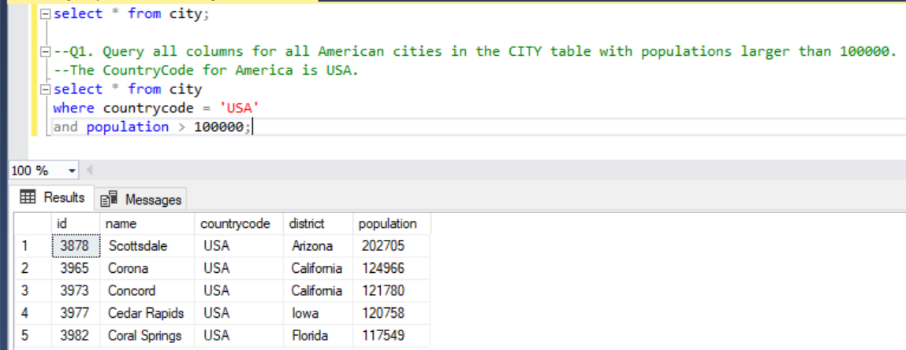

Q2. Query the NAME field for all American cities in the CITY table with populations larger than 120000. The CountryCode for America is USA.

Query:-

select name from city where countrycode = 'USA'and population > 120000;

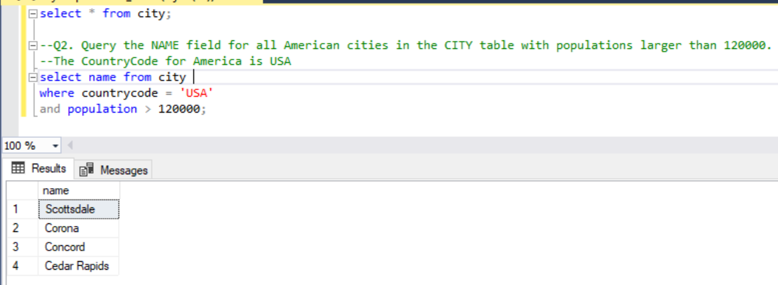

Q3. Query all columns (attributes) for every row in the CITY table.

Query:-

select * from city;

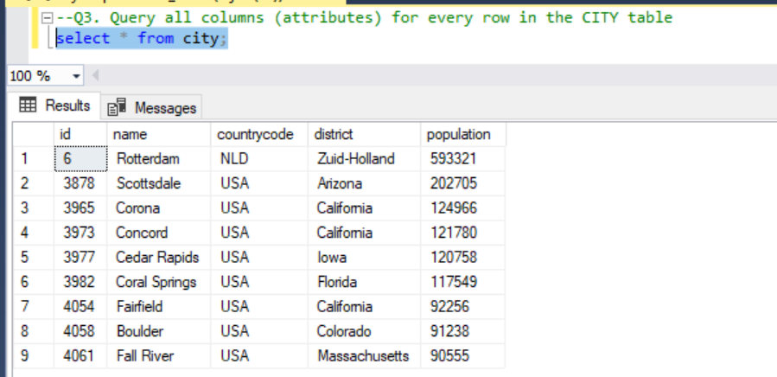

Q4. Query all columns for a city in CITY with the ID 1661.

Query:-

select * from city where id=1661;

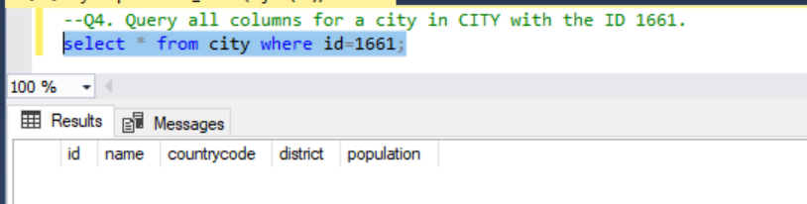

Q5. Query all attributes of every Japanese city in the CITY table. The COUNTRYCODE for Japan is JPN.

Query:-

select * from city where countrycode='JPN';

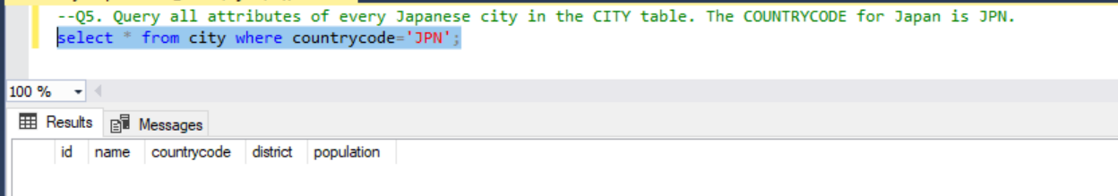

Q6. Query the names of all the Japanese cities in the CITY table. The COUNTRYCODE for Japan is JPN

Query:-

select name from city where countrycode='JPN';

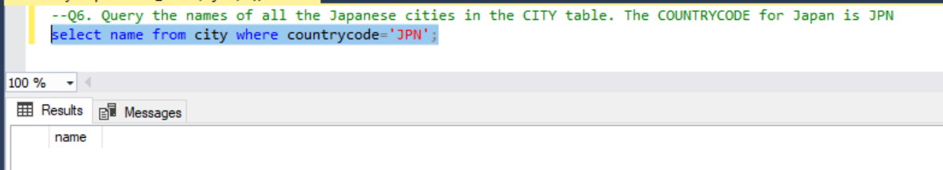

Q7. Query a list of CITY and STATE from the STATION table

Query:-

select city,state from station;

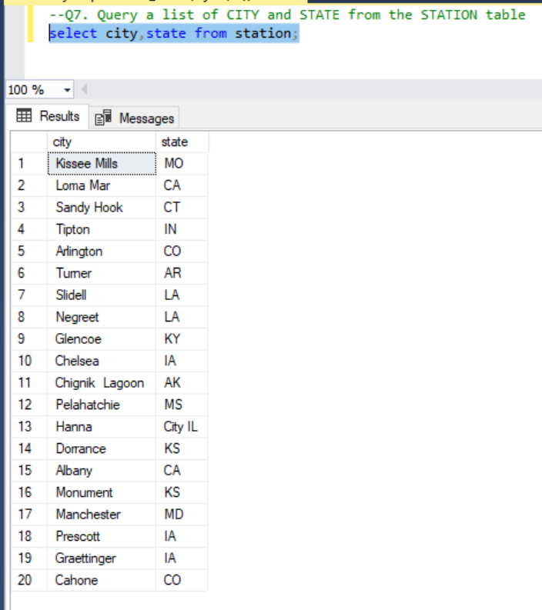

Q8. Query a list of CITY names from STATION for cities that have an even ID number. Print the results in any order, but exclude duplicates from the answer.

Query:-

select distinct(city) as CITY from station where (id % 2) = 0;

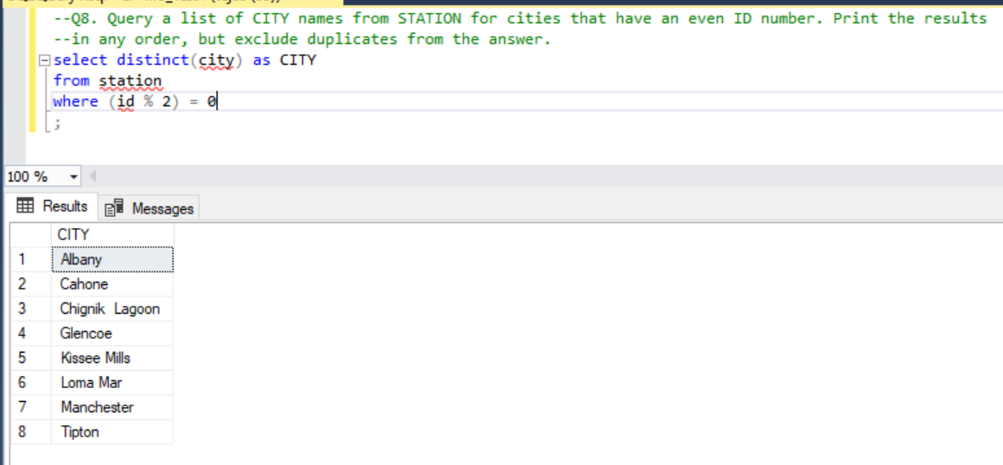

Q9. Find the difference between the total number of CITY entries in the table and the number of distinct CITY entries in the table.

Query:-

select count(city) - count(distinct(city)) as DIFF from station;

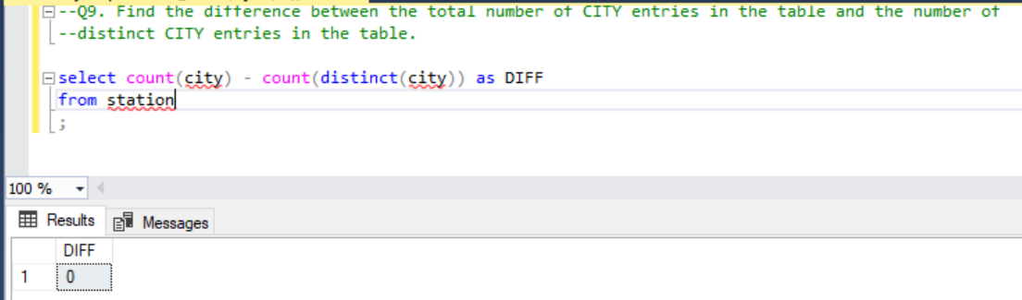

Q10. Query the two cities in STATION with the shortest and longest CITY names, as well as their respective lengths (i.e.: number of characters in the name). If there is more than one smallest or largest city, choose the one that comes first when ordered alphabetically.

Query:-

with t1 as (

select city,

len(city) as length,

row_number() over (order by len(city), city) as smallest_rn,

row_number() over (order by len(city) desc, city) as largest_rn

from station

)

select city, length

from t1

where smallest_rn = 1

union all

select city, length

from t1

where largest_rn = 1

;

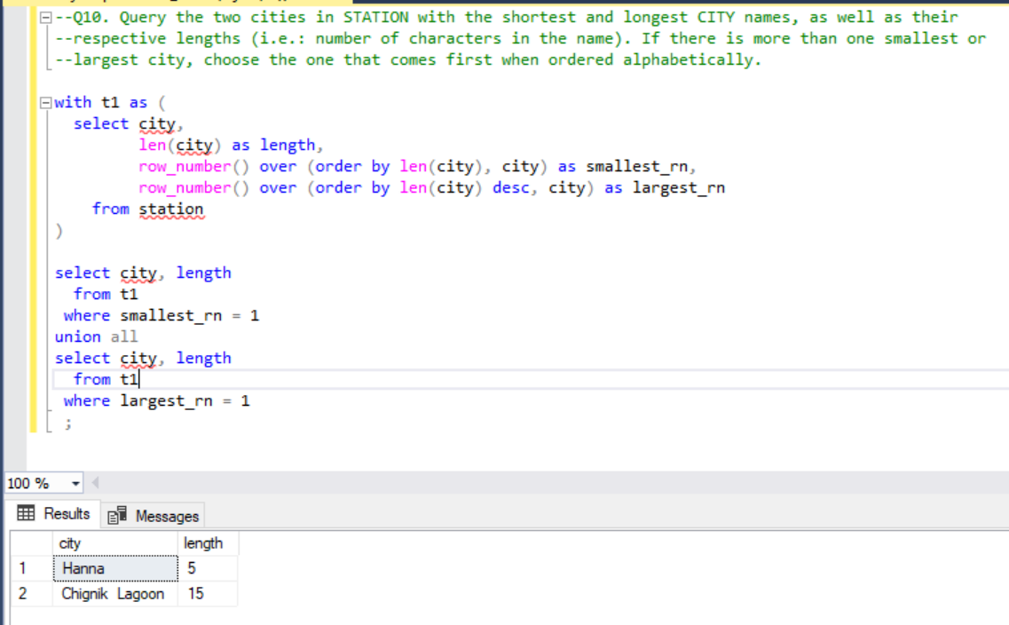

Q11. Query the list of CITY names starting with vowels (i.e., a, e, i, o, or u) from STATION. Your result cannot contain duplicates.

Query:-

select distinct(city) as CITY

from station

where (LOWER(city) like 'a%' or LOWER(city) like 'e%' or LOWER(city) like 'i%' or LOWER(city) like 'o%' or LOWER(city) like 'u%');

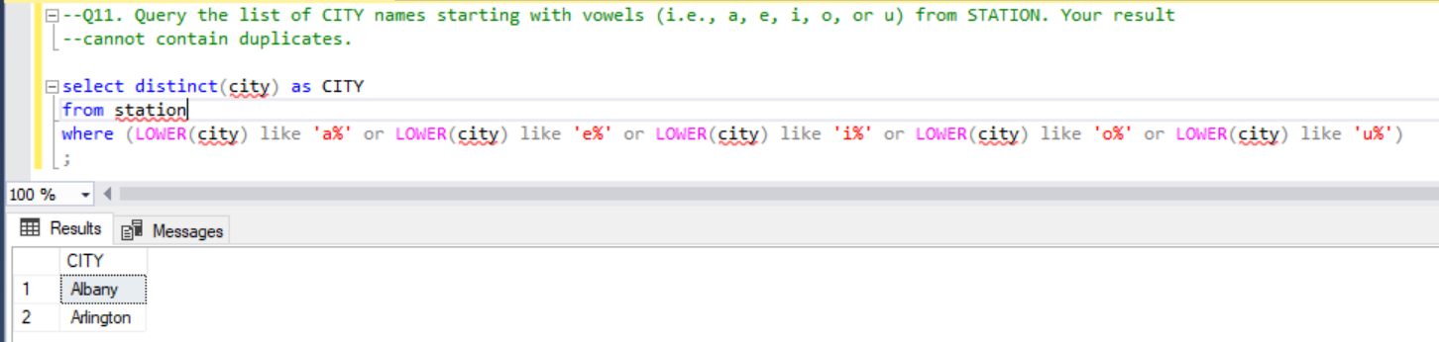

Q12. Query the list of CITY names ending with vowels (a, e, i, o, u) from STATION. Your result cannot contain duplicates

Query:-

select distinct(city) as CITY

from station

where (LOWER(city) like '%a' or LOWER(city) like '%e' or LOWER(city) like '%i' or LOWER(city) like '%o' or LOWER(city) like '%u');

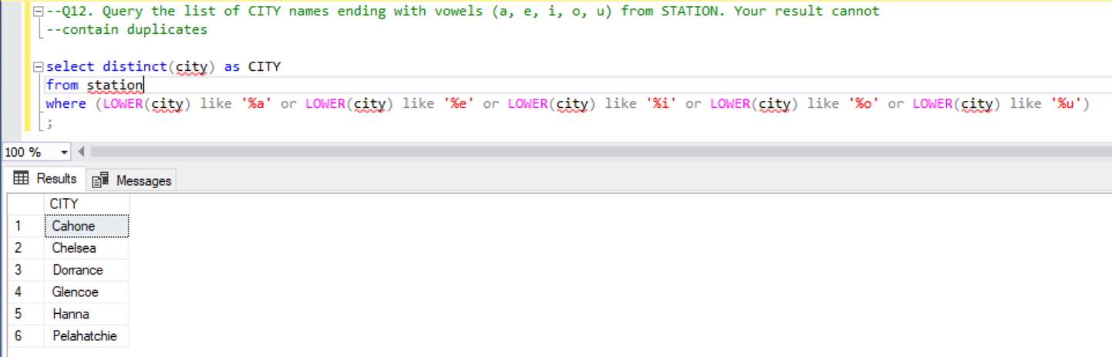

Q13. Query the list of CITY names from STATION that do not start with vowels. Your result cannot contain duplicates.

Query:-

select distinct(city) as CITY

from station

where (LOWER(city) not like 'a%' and LOWER(city) not like 'e%' and LOWER(city) not like 'i%' and LOWER(city) not like 'o%' and LOWER(city) not like 'u%');

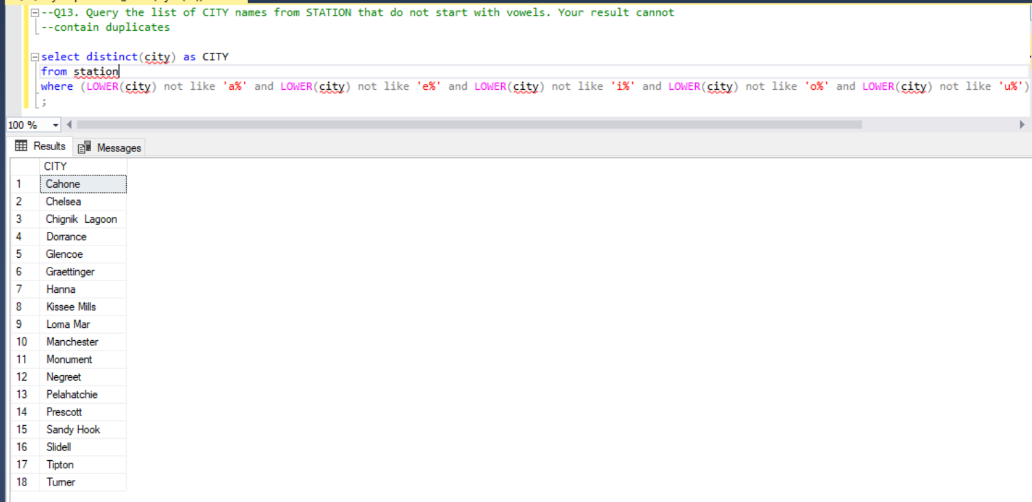

Q14. Query the list of CITY names from STATION that do not end with vowels. Your result cannot contain duplicates.

Query:-

select distinct(city) as CITY

from station

where (LOWER(city) not like '%a' and LOWER(city) not like '%e' and LOWER(city) not like '%i' and LOWER(city) not like '%o' and LOWER(city) not like '%u');

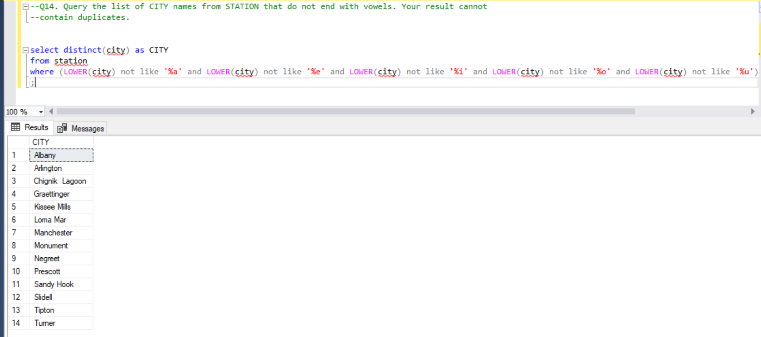

Q15. Query the list of CITY names from STATION that either do not start with vowels or do not end with vowels. Your result cannot contain duplicates.

Query:-

select distinct(city) as CITY

from station

where ((LOWER(city) not like '%a' and LOWER(city) not like '%e' and LOWER(city) not like '%i' and LOWER(city) not like '%o' and LOWER(city) not like '%u')

or

(LOWER(city) not like 'a%' and LOWER(city) not like 'e%' and LOWER(city) not like 'i%' and LOWER(city) not like 'o%' and LOWER(city) not like 'u%'))

;

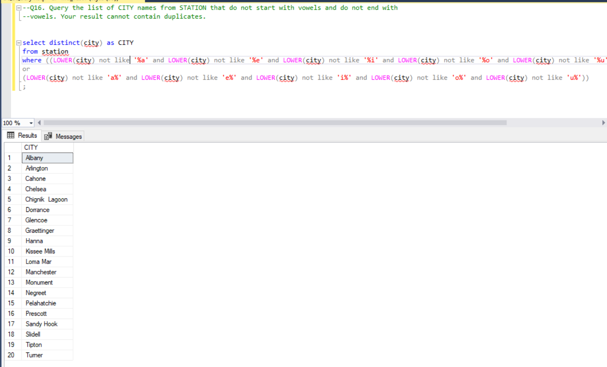

Q16. Query the list of CITY names from STATION that do not start with vowels and do not end with vowels. Your result cannot contain duplicates.

select distinct(city) as CITY

from station

where ((LOWER(city) not like '%a' and LOWER(city) not like '%e' and LOWER(city) not like '%i' and LOWER(city) not like '%o' and LOWER(city) not like '%u')

and

(LOWER(city) not like 'a%' and LOWER(city) not like 'e%' and LOWER(city) not like 'i%' and LOWER(city) not like 'o%' and LOWER(city) not like 'u%'));

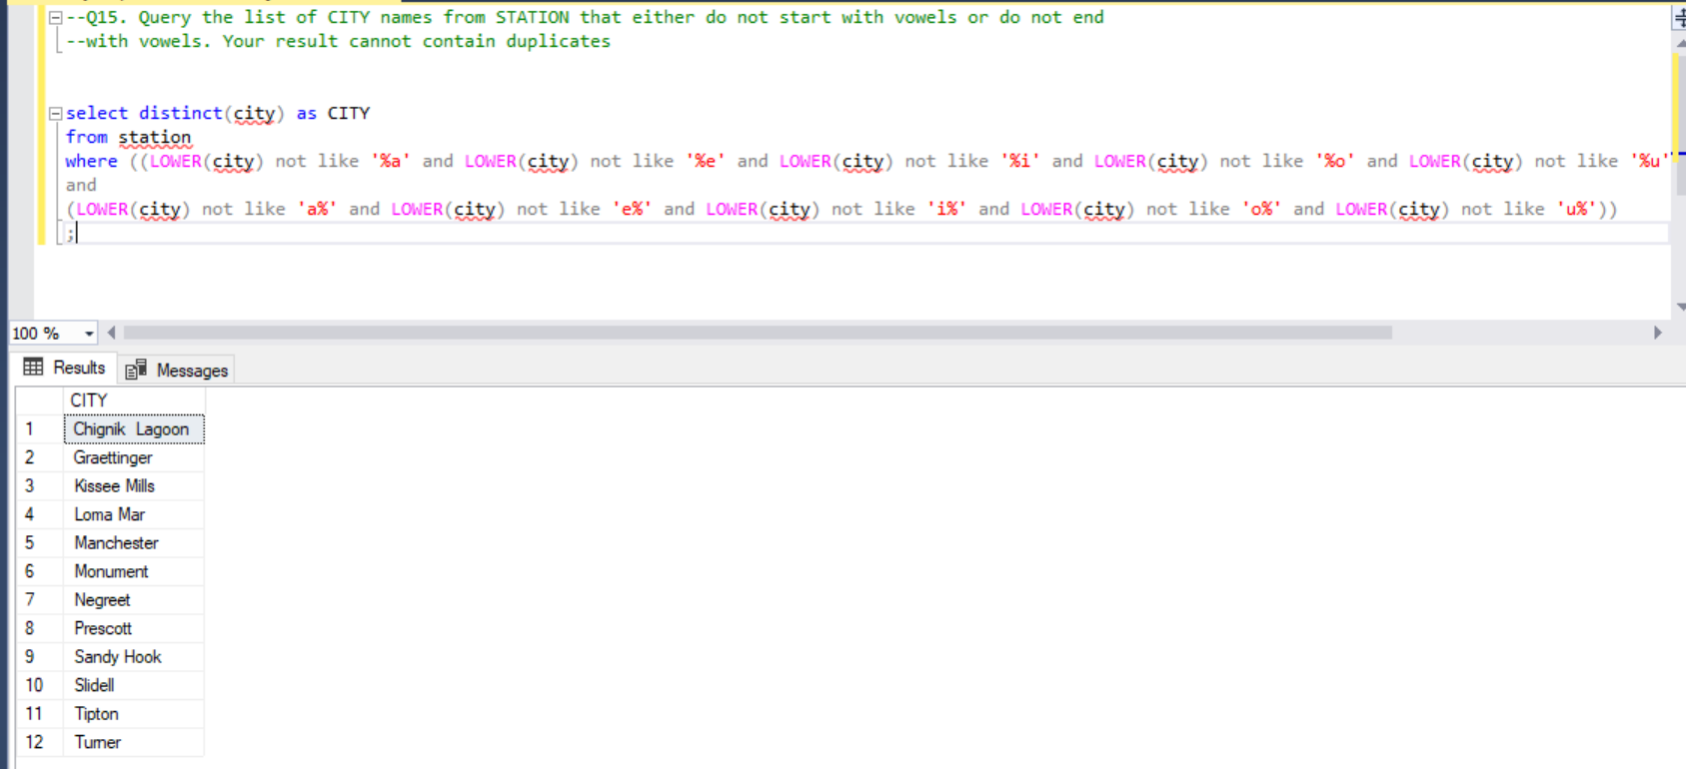

Q17. Write an SQL query that reports the products that were only sold in the first quarter of 2019. That is, between 2019-01-01 and 2019-03-31 inclusive. Return the result table in any order.

select p.product_id, p.product_name

from product p left join sales s

on p.product_id = s.product_id

group by p.product_id, p.product_name

having min(s.sale_date) >= '2019-01-01' and max(s.sale_date) <= '2019-03-31';

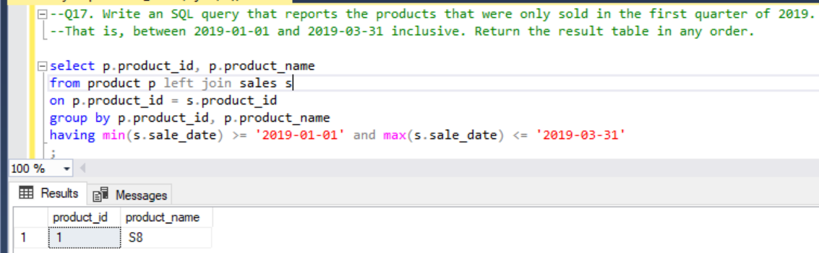

Q18. Write an SQL query to find all the authors that viewed at least one of their own articles. Return the result table sorted by id in ascending order.

select distinct(a.author_id) as id

from views a inner join views b

on a.author_id = b.viewer_id

order by id

;

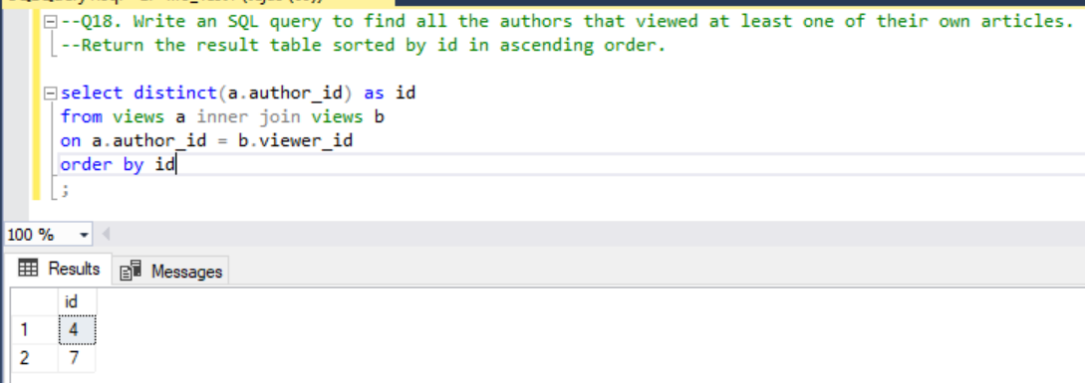

Q19. Write an SQL query to find the percentage of immediate orders in the table, rounded to 2 decimal places.

select cast(

round(

((select count(*) from delivery where order_date = customer_pref_delivery_date) * 100.0)

/

(select count(*) from delivery)

,2) as decimal (19,2))

as immediate_percentage ;

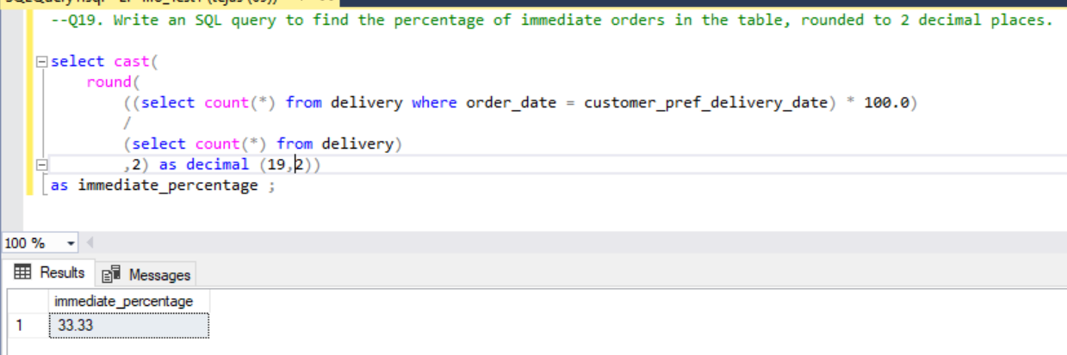

Q20. Write an SQL query to find the ctr of each Ad. Round ctr to two decimal points. Return the result table ordered by ctr in descending order and by ad_id in ascending order in case of a tie.

select ad_id,isnull(cast(((clicked * 100.0)/NULLIF((clicked+viewed),0)) as decimal(10,2)),0) ctr

from(

select ad_id, sum(clicked) clicked,sum(viewed) viewed

from(

select ad_id,

case when action = 'Clicked' then 1 else 0 end as clicked,

case when action = 'Viewed' then 1 else 0 end as viewed,

case when action = 'Ignored' then 1 else null end as ignored

from ads

) tmp

group by ad_id

) tmp2

order by ctr desc, ad_id

;

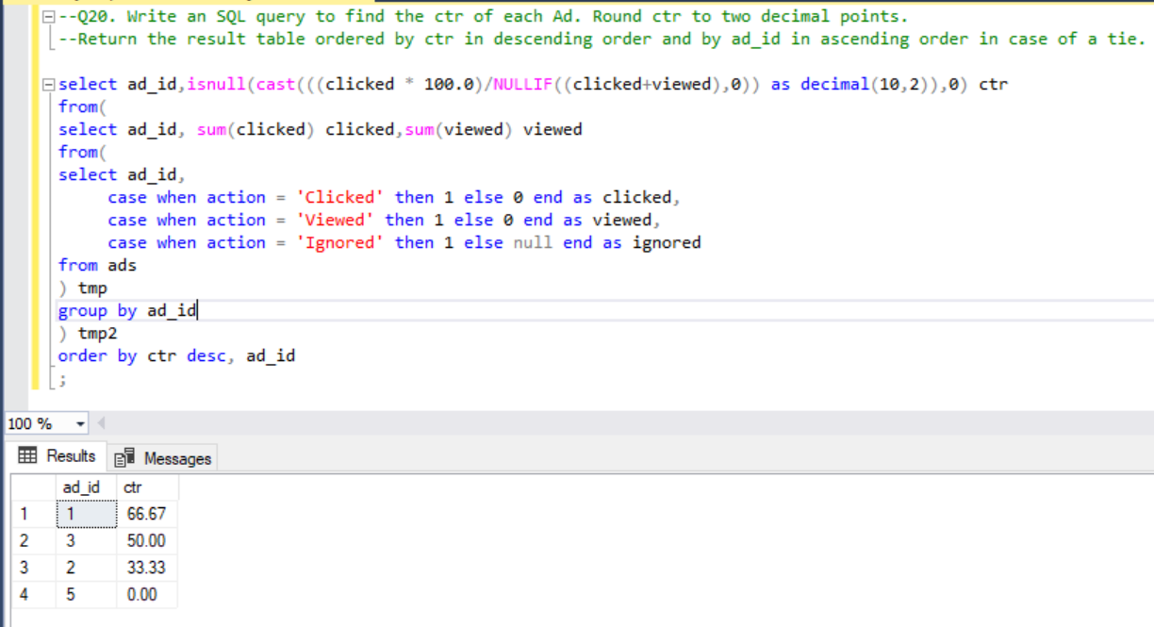

Q21. Write an SQL query to find the team size of each of the employees. Return result table in any order

SELECT employee_id, COUNT(*) OVER (PARTITION BY team_id) team_size

FROM Employee

order by employee_id

;

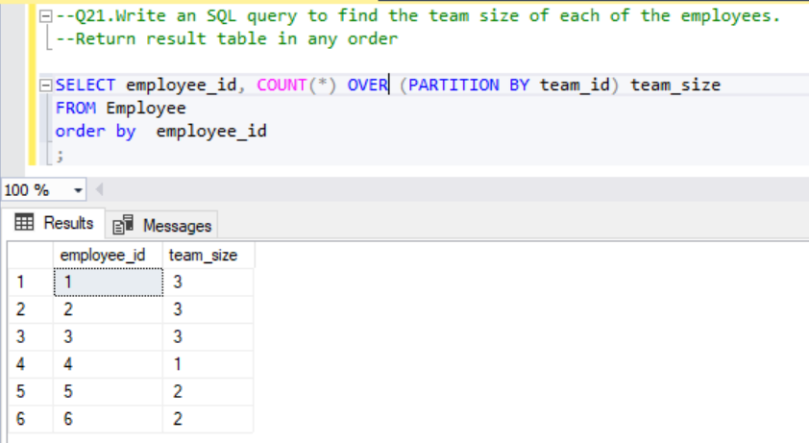

Q22. Write an SQL query to find the type of weather in each country for November 2019

select country_name,

case when weather_state <= 15 then 'Cold'

when weather_state >= 25 then 'Hot'

else 'Warm'

end as weather_type

from

(

select c.country_name as country_name, avg(w.weather_state) as weather_state

from countries c inner join weather w

on c.country_id = w.country_id

where MONTH(day) = 11

group by country_name

) tmp

;

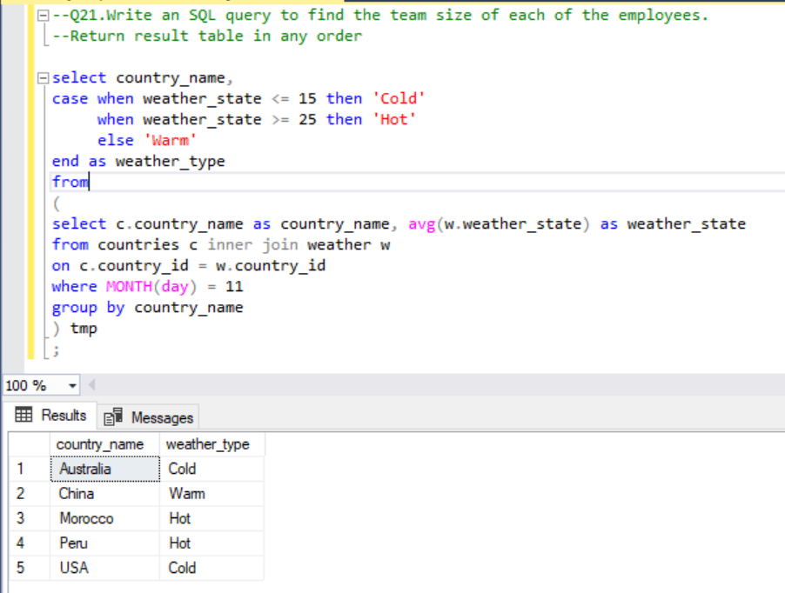

Q23. Write an SQL query to find the average selling price for each product. average_price should be rounded to 2 decimal places.

select product_id, cast(sum((total_price/total_units)) as decimal(10,2)) as average_price

from(

select p.product_id

,sum(units) over (partition by p.product_id) as total_units

,cast((p.price * u.units) as decimal(10,2)) as total_price

from prices p inner join unitsSold u

on p.product_id = u.product_id

where u.purchase_date between p.start_date and p.end_date

) tmp

group by product_id

;

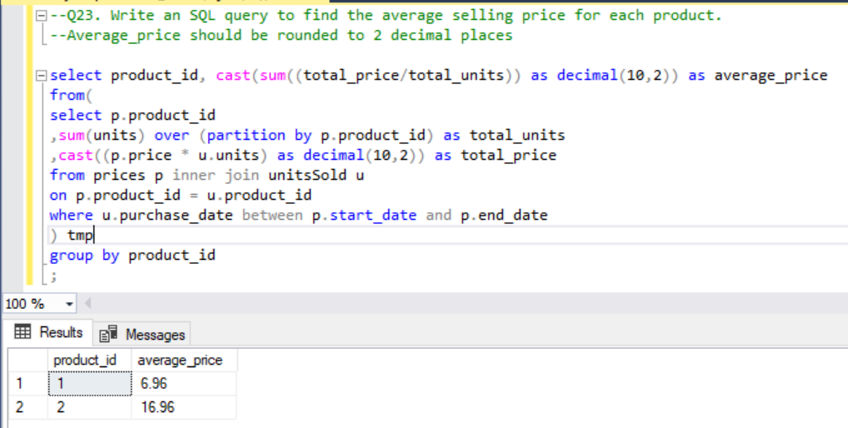

Q24. Write an SQL query to report the first login date for each player. Return the result table in any order.

select player_id, event_date as first_login

from(

select player_id,event_date,

row_number() over (partition by player_id order by event_date) as rn

from activity

) tmp

where rn =1

;

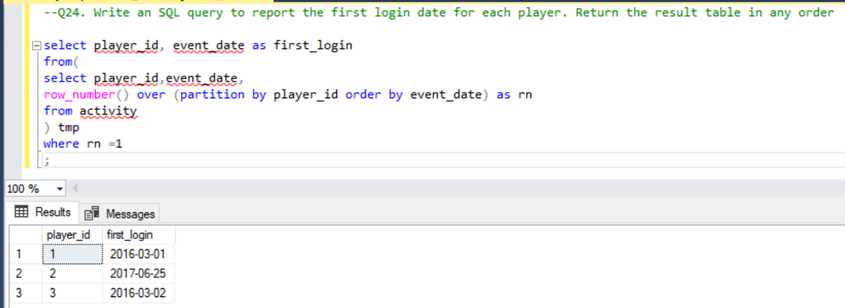

Q25. Write an SQL query to report the device that is first logged in for each player. Return the result table in any order.

select player_id, device_id

from(

select player_id,event_date, device_id,

row_number() over (partition by player_id order by event_date) as rn

from activity

) tmp

where rn =1

;

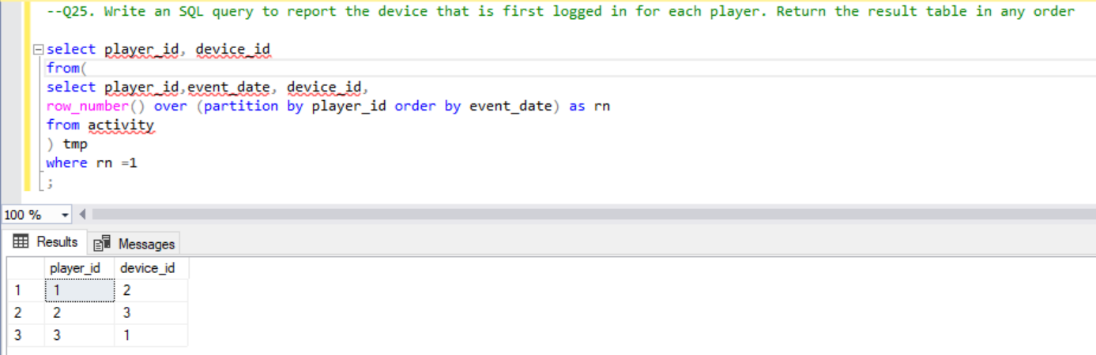

Q26. Write an SQL query to get the names of products that have at least 100 units ordered in February 2020 and their amount. Return result table in any order.

select distinct(product_name), units as unit

from(

select p.product_name,o.unit,

sum(unit) over (partition by p.product_name) as units

from products p inner join orders o

on p.product_id = o.product_id

where MONTH(o.order_date) = 2

) tmp

where units >= 100

;

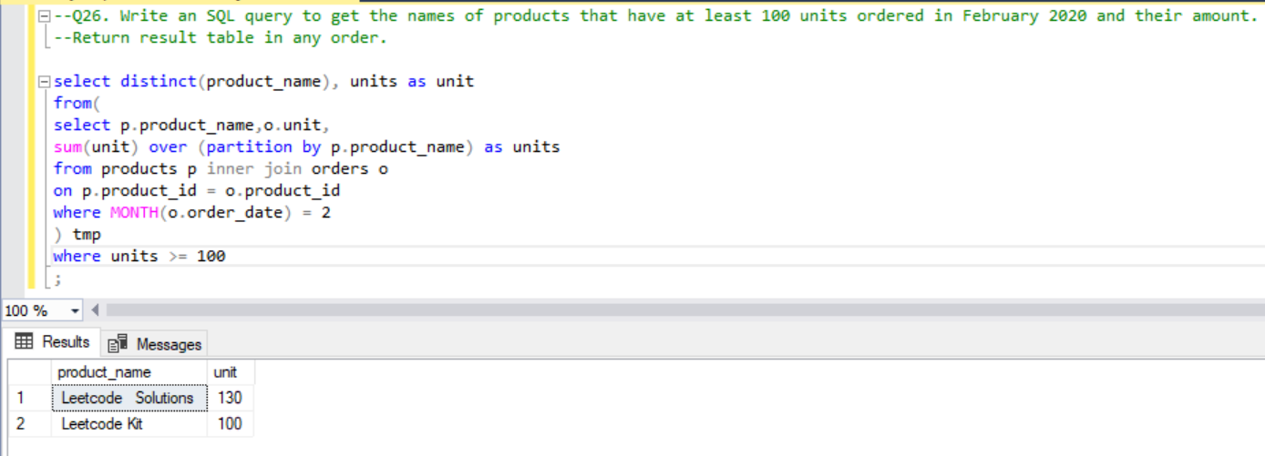

Q27. Write an SQL query to find the users who have valid emails. Return the result table in any order.

SELECT *

FROM users

where mail like '[a-zA-Z0-9\_\.\-]%@leetcode.com'

and mail not like '%#%'

;

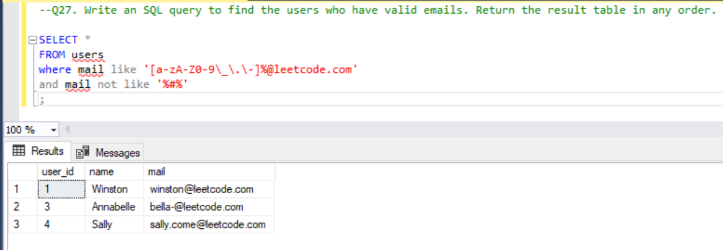

Q28. Write an SQL query to report the customer_id and customer_name of customers who have spent at least $100 in each month of June and July 2020.

--Q28. Write an SQL query to report the customer_id and customer_name of customers

--who have spent at least $100 in each month of June and July 2020

select o.customer_id, name

from

orders_1 o inner join product_1 p

on o.product_id = p.product_id

inner join customers c on o.customer_id = c.customer_id

group by o.customer_id, name

having sum(case when month(o.order_date) = 6 then price*quantity end) >= 100

and sum(case when month(o.order_date) = 7 then price*quantity end) >= 100

;

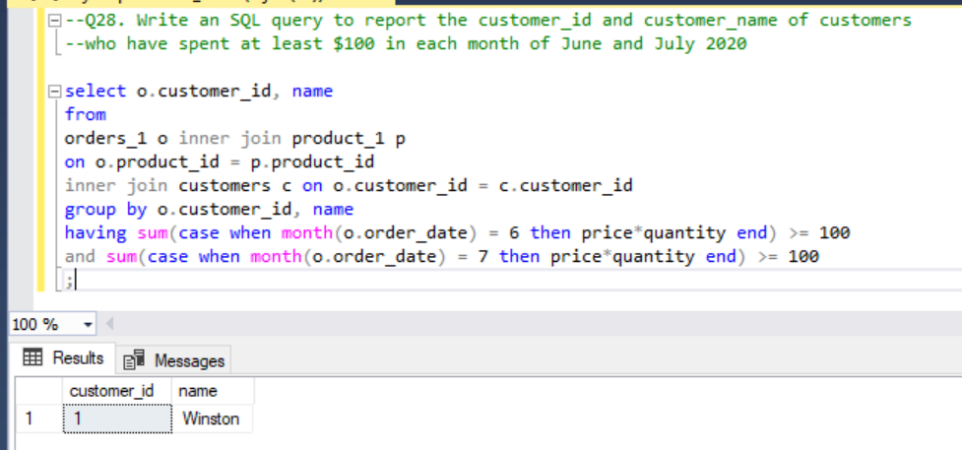

Q29. Write an SQL query to report the distinct titles of the kid-friendly movies streamed in June 2020. Return the result table in any order.

select c.title

from tvprogram t inner join content c

on t.content_id = c.content_id

where YEAR(t.program_date) = 2020 and MONTH(t.program_date) = 6

and c.kids_content = 'Y'

;

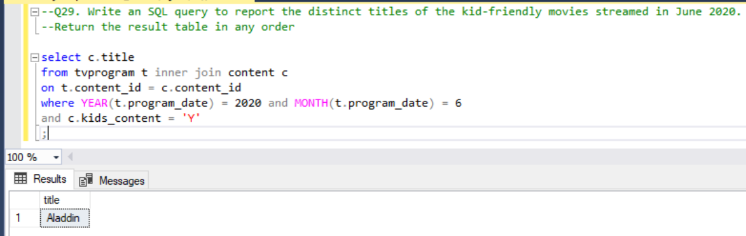

Q.30 Write an SQL query to find the npv of each query of the Queries table. Return the result table in any order

Select q.id, q.year, ISNULL(n.npv,0) npv

from queries q left join npv n

on n.id = q.id

and n.year = q.year

;

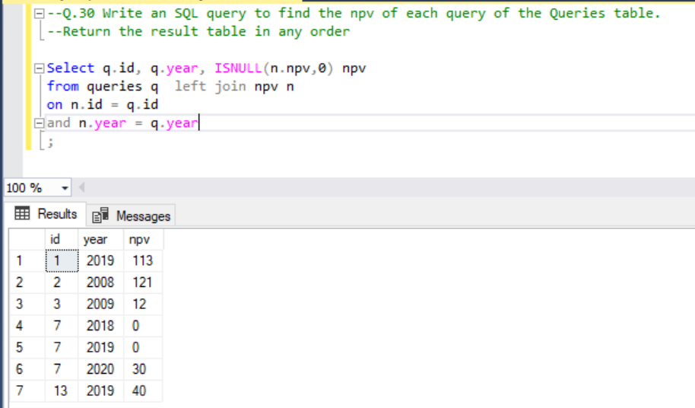

Q32. Write an SQL query to show the unique ID of each user, If a user does not have a unique ID replace just show null. Return the result table in any order.

select u.unique_id, e.name

from employees_1 e left join employeeUNI u

on e.id = u.id

;

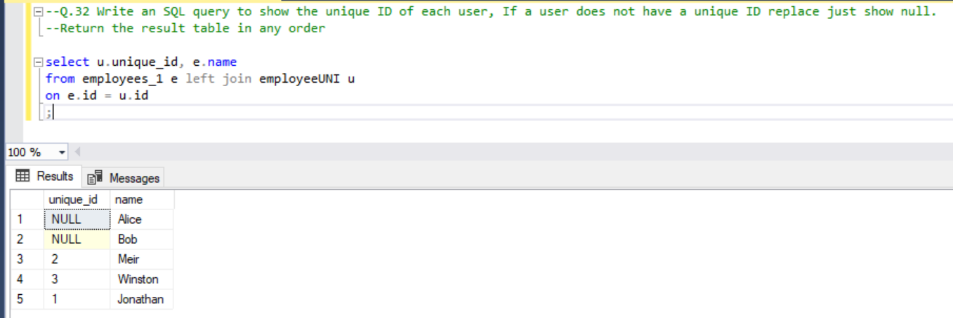

Q33. Write an SQL query to report the distance travelled by each user. Return the result table ordered by travelled_distance in descending order, if two or more users travelled the same distance, order them by their name in ascending order.

select u.name, sum(isnull(r.distance,0)) travelled_distance

from users_1 u left join rides r

on u.id = r.user_id

group by u.name

order by travelled_distance desc, u.name

;

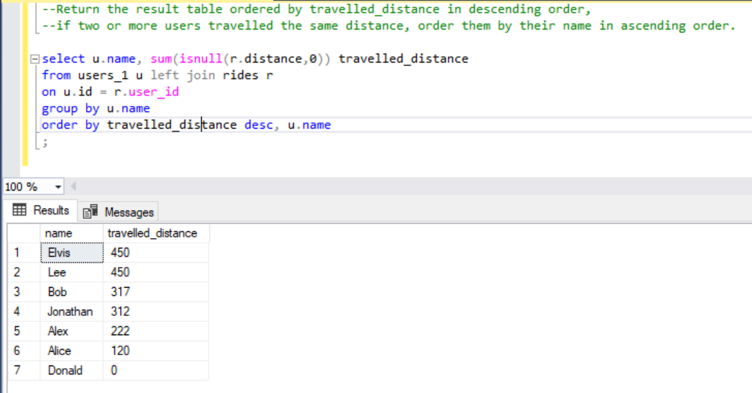

Q35. Write an SQL query to: ● Find the name of the user who has rated the greatest number of movies. In case of a tie, return the lexicographically smaller user name. ● Find the movie name with the highest average rating in February 2020. In case of a tie, return the lexicographically smaller movie name

SELECT user_name AS results FROM

(

SELECT top(1) a.name AS user_name, COUNT(*) AS counts

FROM movierating b inner JOIN users_2 a

on a.user_id = b.user_id

GROUP BY a.name

ORDER BY counts DESC, user_name ASC

) first_query

UNION

SELECT movie_name AS results FROM

(

SELECT top (1) c.title AS movie_name, sum(d.rating)/cast(count(*) as decimal(10,2)) AS rate FROM movierating AS d

inner JOIN movies AS c

on c.movie_id = d.movie_id

WHERE MONTH(d.created_at) = 2 and YEAR(d.created_at) = 2020

GROUP BY c.title

ORDER BY rate DESC, movie_name ASC

) second_query;

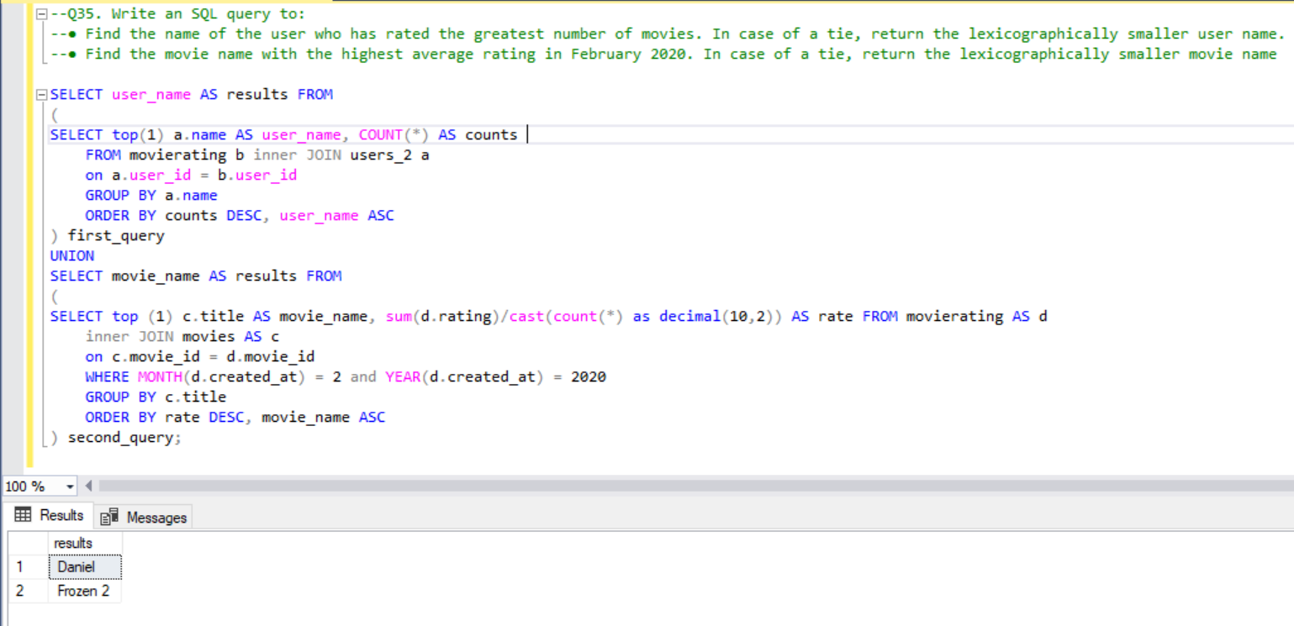

Q38. Write an SQL query to find the id and the name of all students who are enrolled in departments that no longer exist.

select id,name

from students where id not in (

select s.id

from students s inner join department d

on s.dept_id = d.id

)

;

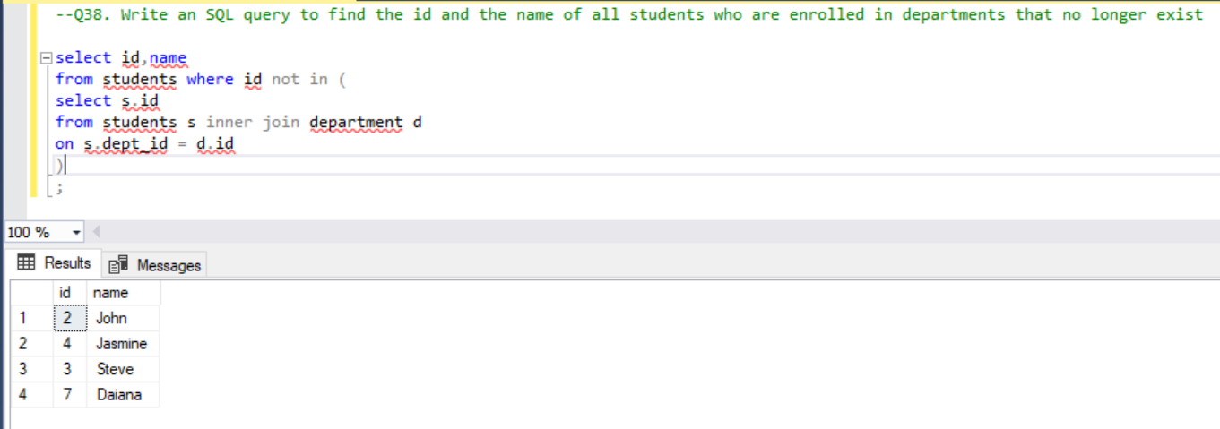

Q39. Write an SQL query to report the number of calls and the total call duration between each pair of distinct persons (person1, person2) where person1 < person2.

WITH caller as (

select from_id as person1, to_id as person2, duration

from Calls

UNION ALL

select to_id as person1, from_id as person2, duration

from Calls

),

unique_caller as (

select person1, person2, duration

from caller

where person1 < person2

)

select

person1, person2, count(*) as call_count, sum(duration) as total_duration

from unique_caller

group by person1, person2

;

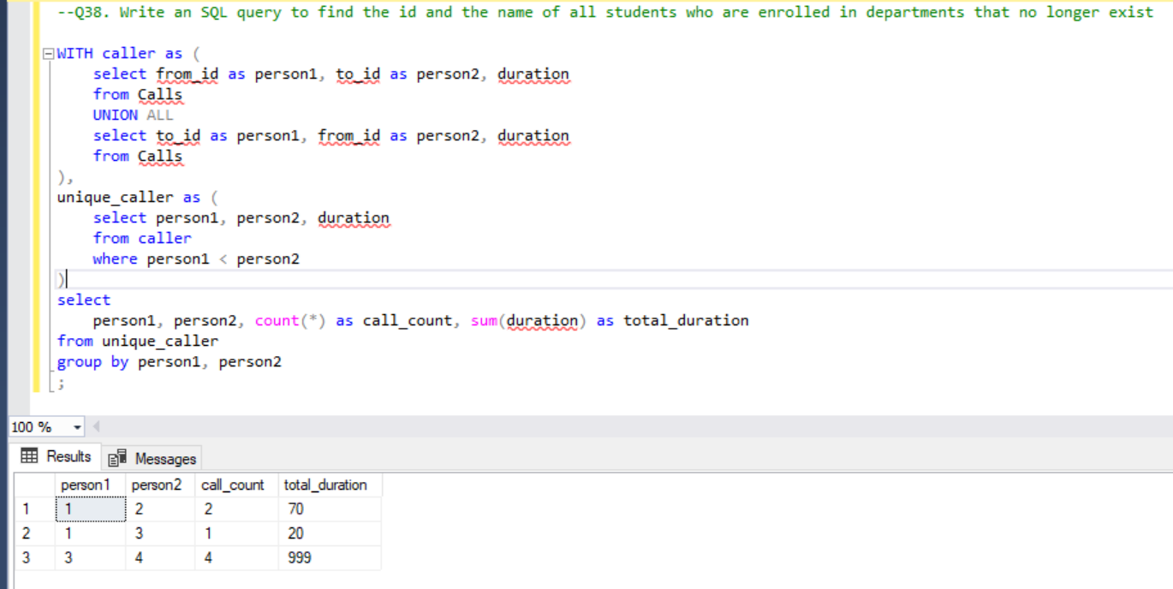

Q41. Write an SQL query to report the number of cubic feet of volume the inventory occupies in each warehouse.

select w.name warehouse_name, sum(w.units *(p.width * p.length * p.height)) volumne

from warehouse w inner join products_1 p

on w.product_id = p.product_id

group by w.name

;

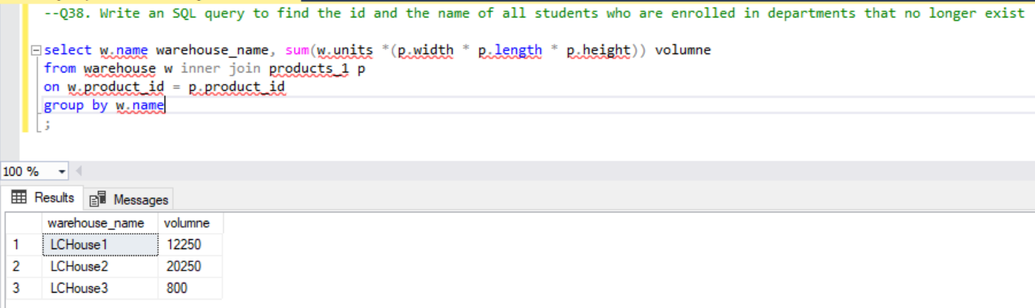

Q42. Write an SQL query to report the difference between the number of apples and oranges sold each day. Return the result table ordered by sale_date.

select a.sale_date, a.sold_num - b.sold_num as diff

from sales_1 a inner join sales_1 b

on a.sale_date = b.sale_date

where a.fruit = 'apples' and b.fruit = 'oranges'

order by a.sale_date

;

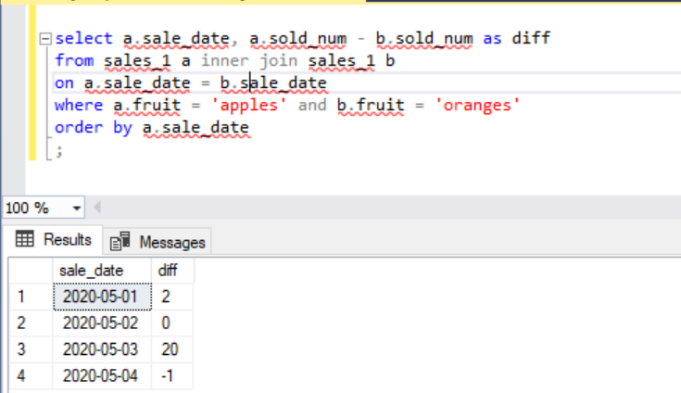

Q43. Write an SQL query to report the fraction of players that logged in again on the day after the day they first logged in, rounded to 2 decimal places.

WITH CTE AS (

SELECT

player_id, min(event_date) as event_start_date

from

Activity

group by player_id )

SELECT

cast(

round((count(distinct c.player_id) / (select cast(count(distinct player_id) as decimal(5,2)) from activity)),2)

as decimal (5,2)

)as fraction

FROM

CTE c

JOIN Activity a

on c.player_id = a.player_id

and datediff(day,c.event_start_date, a.event_date) = 1;

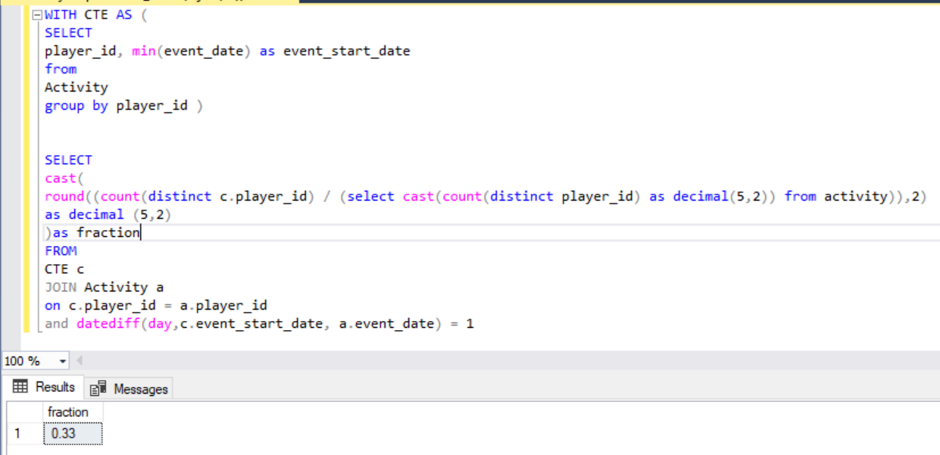

Q44. Write an SQL query to report the managers with at least five direct reports. Return the result table in any order

select name from

(

select a.name, count(*) direct_reports

from employees a inner join employees b

on a.id = b.managerid

group by a.name

) tmp

where direct_reports >= 5;

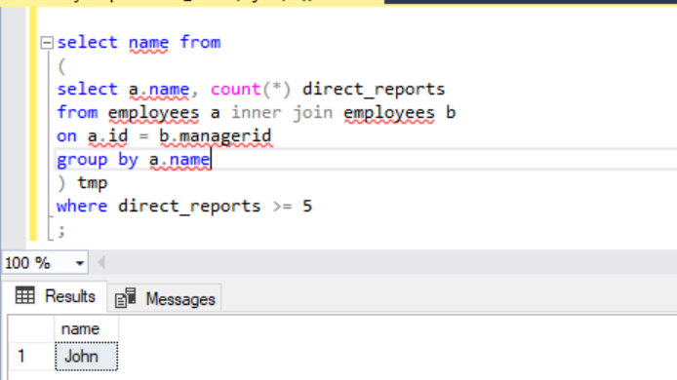

Q45. Write an SQL query to report the respective department name and number of students majoring in each department for all departments in the Department table (even ones with no current students). Return the result table ordered by student_number in descending order. In case of a tie, order them by dept_name alphabetically.

select d.dept_name, count(s.student_id) student_number

from department_1 d left join student s

on s.dept_id = d.dept_id

group by d.dept_name

order by student_number desc, d.dept_name

;

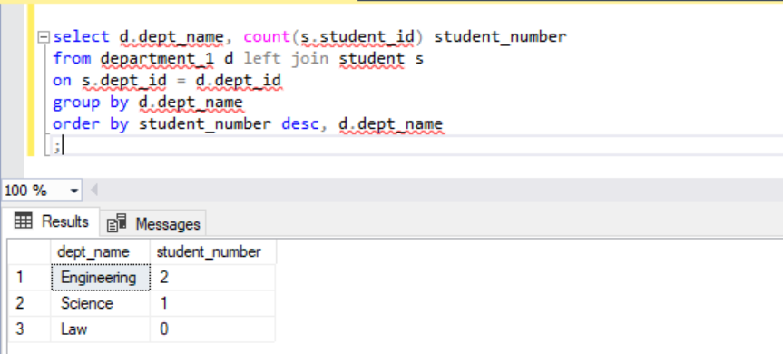

Q46. Write an SQL query to report the customer ids from the Customer table that bought all the products in the Product table

select customer_id

from (

select c.customer_id, count(p.product_key) as pp

from customer c inner join product_3 p

on c.product_key = p.product_key

group by c.customer_id

) tmp

where pp = 2

;

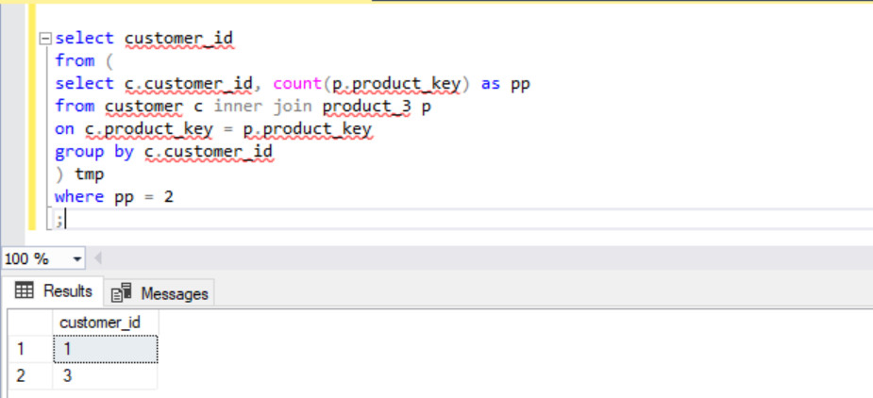

Q47. Write an SQL query that reports the most experienced employees in each project. In case of a tie, report all employees with the maximum number of experience years

SELECT

project_id,

employee_id

FROM (

SELECT

p.project_id,

p.employee_id,

DENSE_RANK() OVER(PARTITION BY p.project_id ORDER BY e.experience_years DESC) as rnk

FROM project as p JOIN emp as e

ON p.employee_id = e.employee_id

) x

WHERE rnk = 1

;

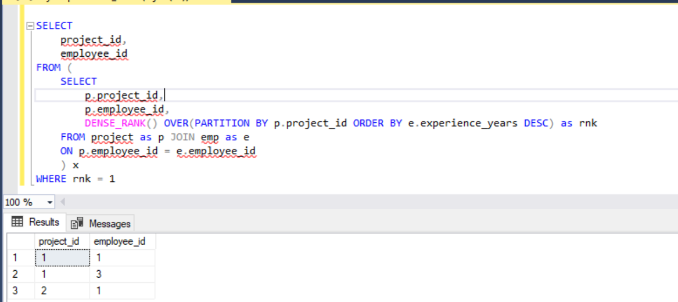

Q49. Write a SQL query to find the highest grade with its corresponding course for each student. In case of a tie, you should find the course with the smallest course_id. Return the result table ordered by student_id in ascending order.

select student_id,course_id,grade

from(

select *,

rank() over(partition by student_id order by grade desc,course_id) as rnk

from enrollments

)tmp

where rnk =1;

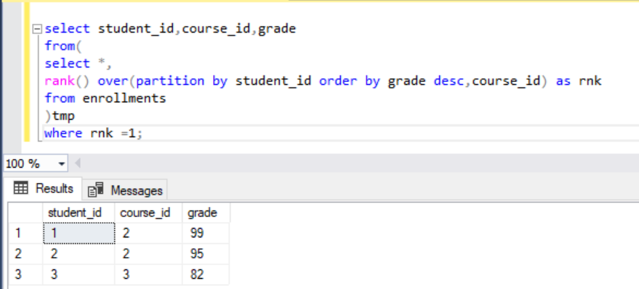

Q51. Write an SQL query to report the name, population, and area of the big countries. Return the result table in any order

select name, population, area

from world

where area >= 3000000

or population >= 25000000

;

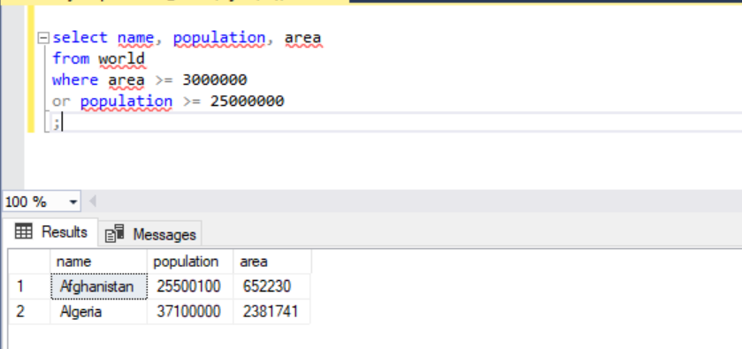

Q52. Write an SQL query to report the names of the customer that are not referred by the customer with id = 2

select name

from customer1 where isnull(referee_id,0) != 2;

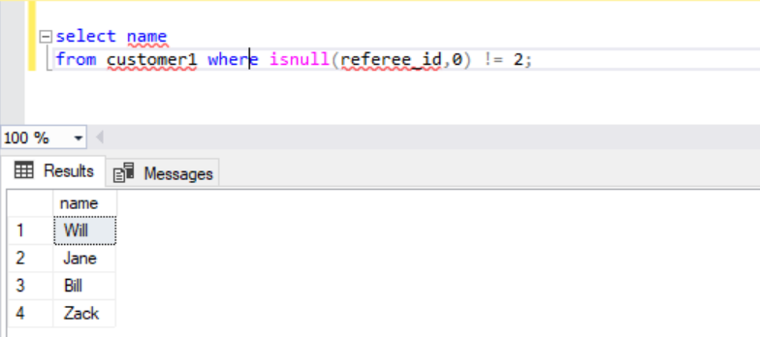

Q53. Write an SQL query to report all customers who never order anything. Return the result table in any order.

select name as customer_names

from cust

where id not in (select customerid from orders1);

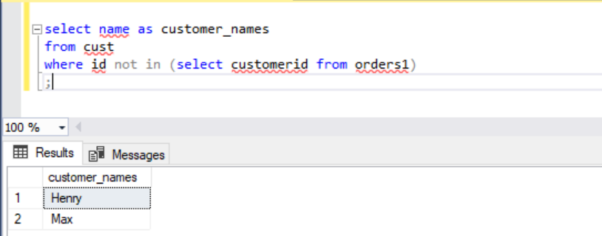

Q55. Write an SQL query to find the countries where this company can invest. Return the result table in any order.

with people_country as

(

select id, c.name country

from Person p left join Country c

on cast(cast(left(p.phone_number,3) as int) as varchar) = c.country_code

)

select country

from

(

select country, avg(duration) avgtime

from

(

select caller_id id, duration

from Call

union all

select callee_id, duration

from Call

) t left join people_country pc

on t.id = pc.id

group by country

) temp

where avgtime >

(

select avg(duration) avgtime

from

(

select caller_id, duration

from Call

union all

select callee_id, duration

from Call

) t

)

;

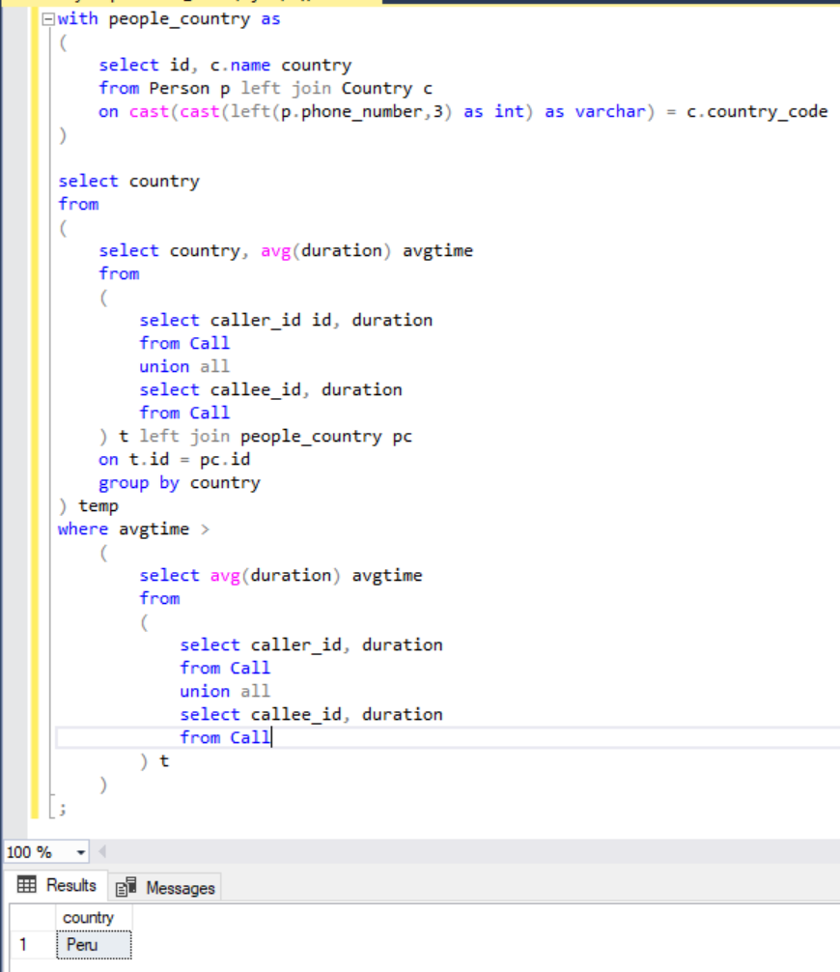

Q57. Write an SQL query to find the customer_number for the customer who has placed the largest number of orders.

select customer_number

from

(

select customer_number

,rank() over(order by count desc) as rnk

from(

SELECT customer_number, COUNT(DISTINCT order_number) count

FROM orders2

GROUP BY customer_number

)tmp

) tmp2

where rnk = 1

;

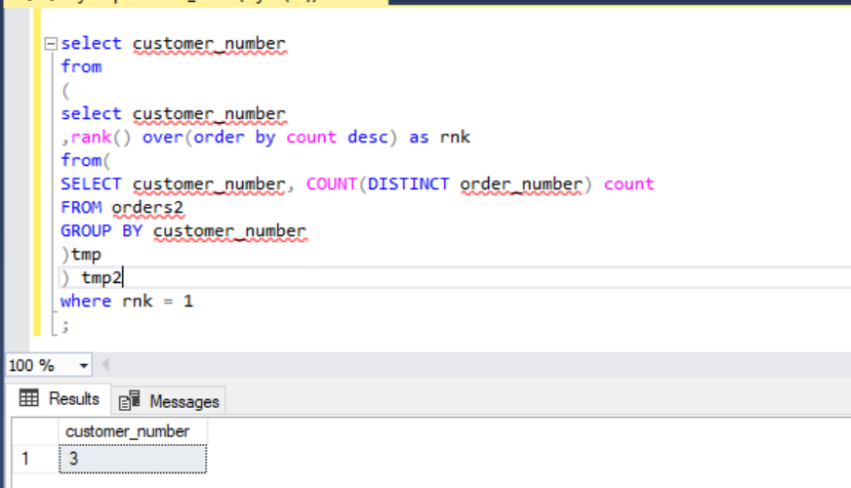

Q58. Write an SQL query to report all the consecutive available seats in the cinema. Return the result table ordered by seat_id in ascending order.

SELECT

DISTINCT t1.seat_id

FROM cinema AS t1 JOIN cinema AS t2

ON abs(t1.seat_id - t2.seat_id) = 1

AND t1.free = 1 AND t2.free = 1

ORDER BY 1

;

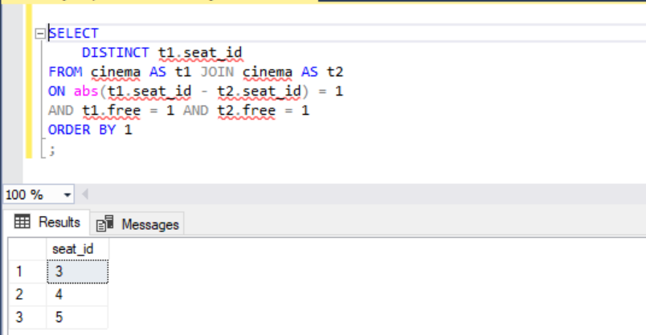

Q59. Write an SQL query to report the names of all the salespersons who did not have any orders related to the company with the name "RED". Return the result table in any order.

select name from SalesPerson

where name not in (

select s.name

from SalesPerson s inner join Orders3 o

on s.sales_id = o.sales_id

inner join Company c

on c.com_id = o.com_id

where c.name = 'RED'

)

;

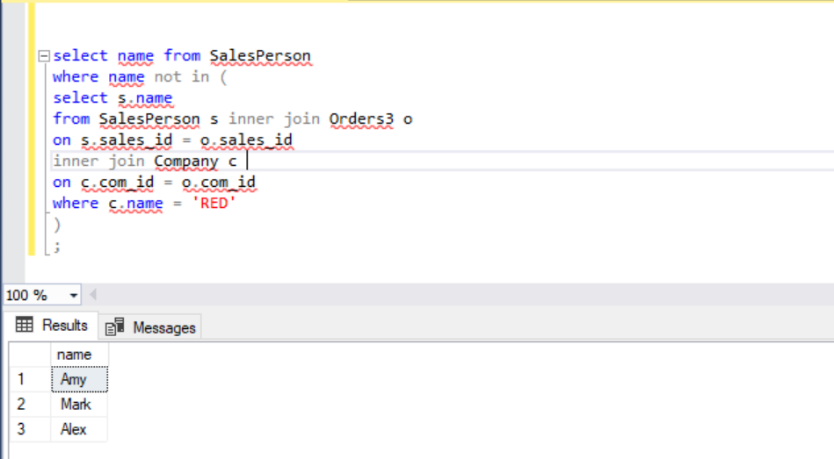

Q60. Write an SQL query to report for every three line segments whether they can form a triangle. Return the result table in any order.

select x,y,z,

case when side_one =1 and side_two = 1 and side_three=1 then 'Yes' else 'No' end as triangle

from(

select t.*,

case when (x+y) > z then 1 else 0 end as side_one,

case when (y+z) > x then 1 else 0 end as side_two,

case when (x+z) > y then 1 else 0 end as side_three

from Triangle t

) tmp

where side_one =1 and side_two = 1 and side_three=1

;

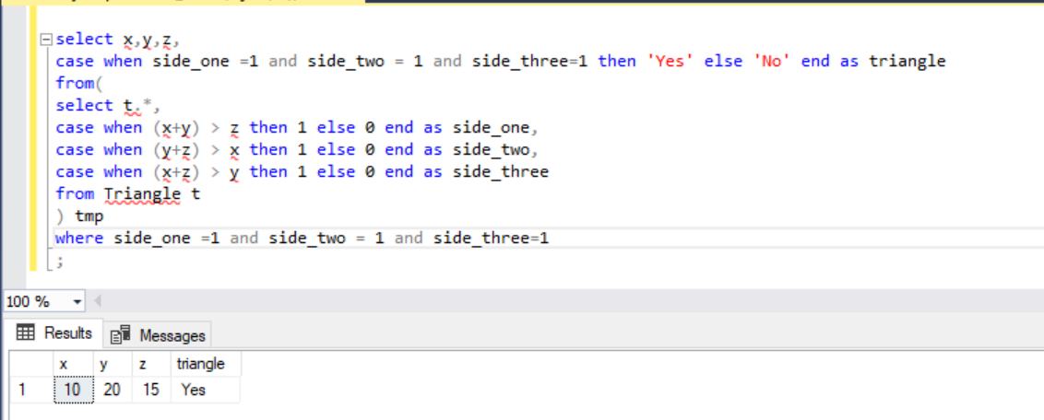

Q61. Write an SQL query to report the shortest distance between any two points from the Point table. The query result format is in the following example.

select TOP(1) abs(x-next_val) as shortest

from(

select *,

lag(x) over(order by x) as next_val

from point

) tmp

where abs(x-next_val) is not null

order by shortest

;

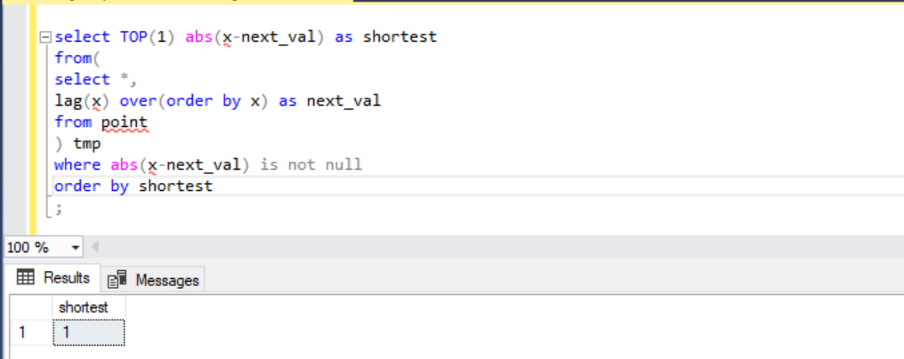

Q62. Write a SQL query for a report that provides the pairs (actor_id, director_id) where the actor has cooperated with the director at least three times. Return the result table in any order.

SELECT actor_id, director_id

FROM ActorDirector

GROUP BY actor_id, director_id

HAVING COUNT(*) >= 3

;

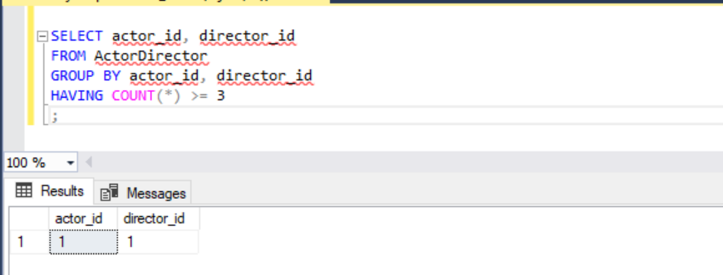

Q63. Write an SQL query that reports the product_name, year, and price for each sale_id in the Sales table. Return the resulting table in any order.

select p.product_name, s.year, s.price

from Sales1 s inner join Product1 p

on s.product_id = p.product_id

;

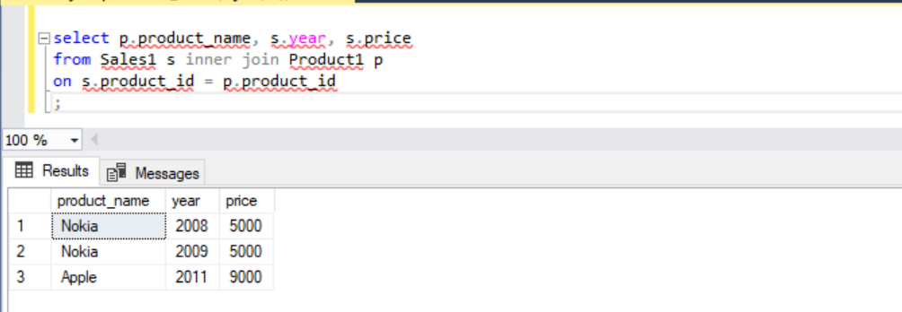

Q64. Write an SQL query that reports the average experience years of all the employees for each project, rounded to 2 digits. Return the result table in any order.

select p.project_id, avg(cast(e.experience_years as decimal(10,2))) as average_years

from emp e inner join project p

on e.employee_id = p.employee_id

group by p.project_id

;

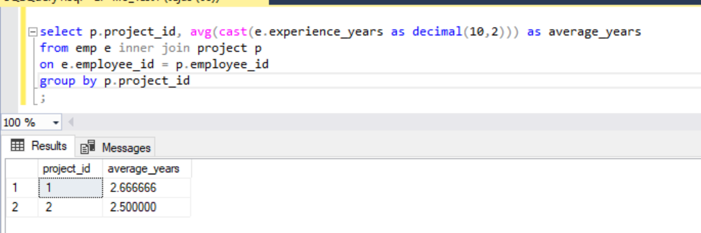

Q65. Write an SQL query that reports the best seller by total sales price, If there is a tie, report them all. Return the result table in any order.

select seller_id from (

select seller_id,

rank() over(order by total_sales desc) as rnk

from(

select s.seller_id, sum(s.price) total_sales

from product p inner join sales s

on p.product_id = s.product_id

group by s.seller_id

) tmp

) tmp2

where rnk = 1

;

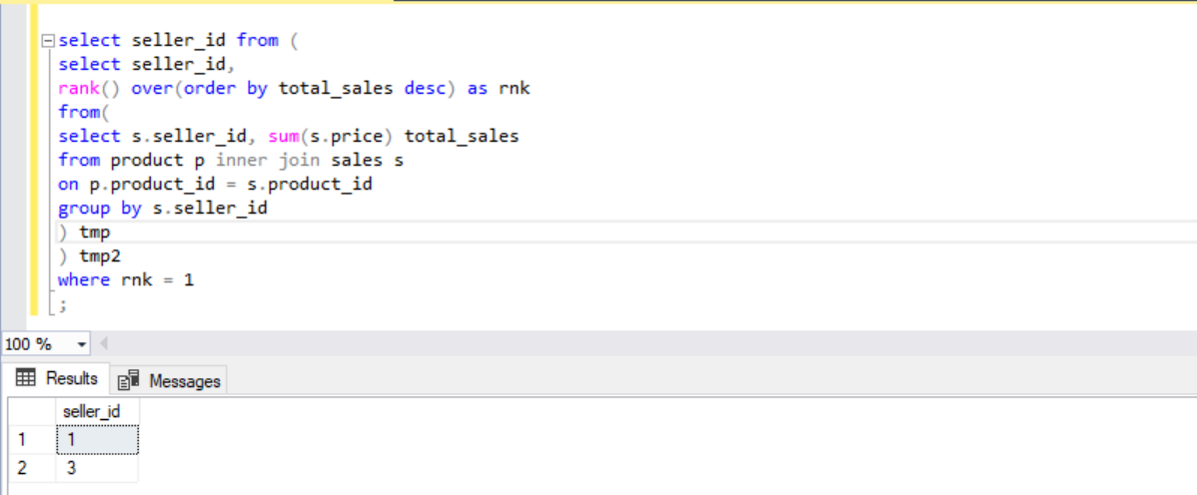

Q66. Write an SQL query that reports the buyers who have bought S8 but not iPhone. Note that S8 and iPhone are products present in the Product table. Return the result table in any order.

select buyer_id

from (

select s.buyer_id, STRING_AGG(p.product_name,', ') as products_buy

from product p inner join sales s

on p.product_id = s.product_id

where p.product_name in ('S8','iPhone')

group by s.buyer_id

having STRING_AGG(p.product_name,', ') = 'S8'

) tmp;

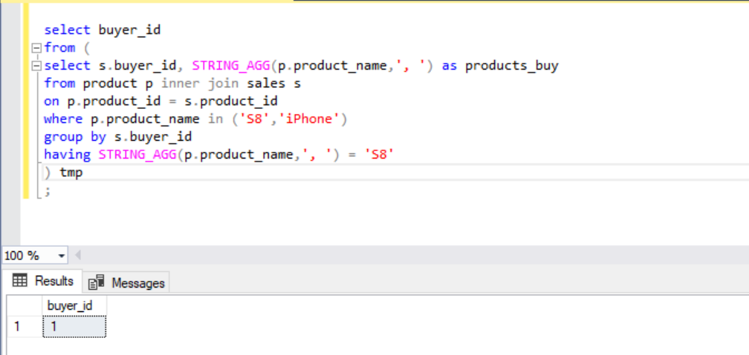

Q67. Write an SQL query to compute the moving average of how much the customer paid in a seven days window (i.e., current day + 6 days before). average_amount should be rounded to two decimal places. Return result table ordered by visited_on in ascending order.

WITH result as (

SELECT

visited_on,

cast(SUM(amount) as decimal(8,2)) as amount

FROM customer2

GROUP BY visited_on

), result2 as (

SELECT

visited_on,

SUM(amount) OVER(ORDER BY visited_on ROWS BETWEEN 6 PRECEDING AND CURRENT ROW) as amount,

ROUND(AVG(amount) OVER(ORDER BY visited_on ROWS BETWEEN 6 PRECEDING AND CURRENT ROW),2) as average_amount,

DENSE_RANK() OVER(ORDER BY visited_on) as rnk

FROM result

)

SELECT

visited_on,

amount,

average_amount

FROM result2

WHERE rnk > 6;

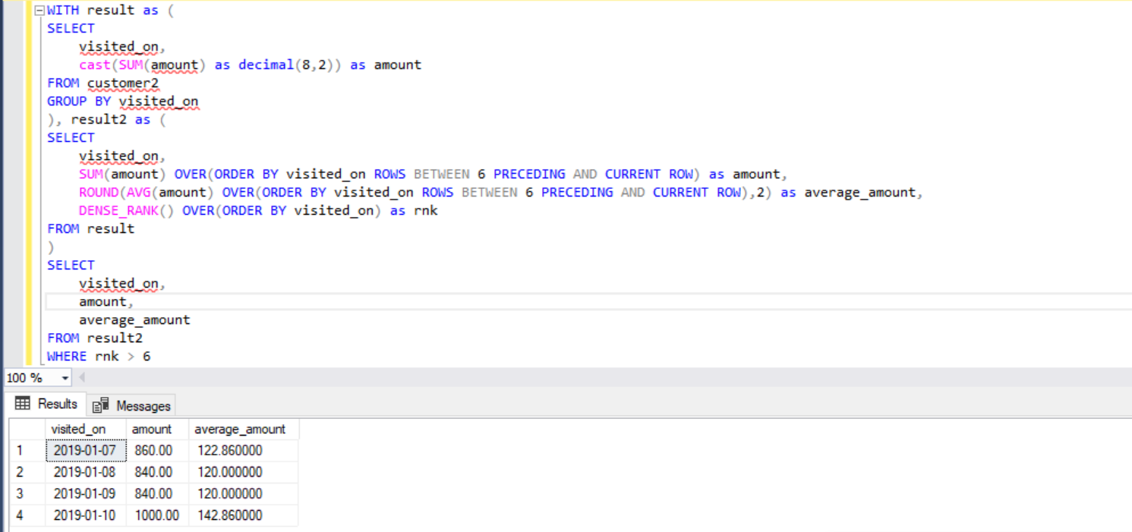

Q68. Write an SQL query to find the total score for each gender on each day. Return the result table ordered by gender and day in ascending order.

select gender, day,

sum(score_points) over(partition by gender order by gender, day) as total

from scores

;

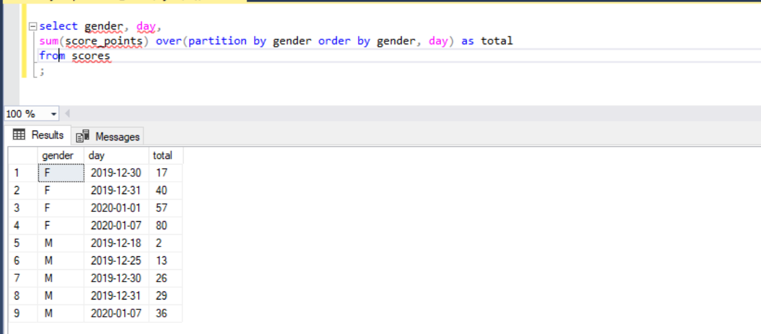

Q69. Write an SQL query to find the start and end number of continuous ranges in the table Logs. Return the result table ordered by start_id.

select log_start.log_id as start_id, min(log_end.log_id) as end_id from

(select log_id from logs where log_id - 1 not in (select * from Logs)) log_start,

(select log_id from logs where log_id + 1 not in (select * from Logs)) log_end

where log_start.log_id <= log_end.log_id

group by log_start.log_id;

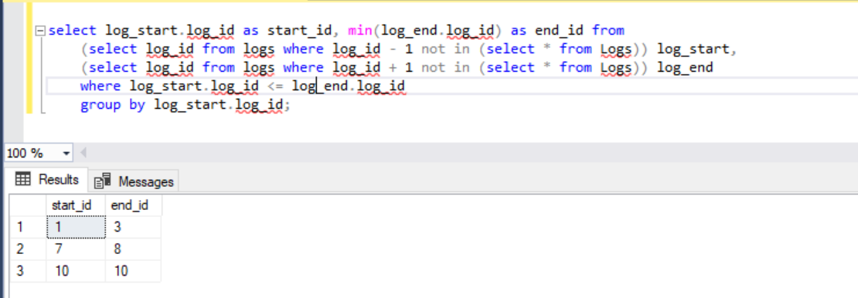

Q70. Write an SQL query to find the number of times each student attended each exam. Return the result table ordered by student_id and subject_name.

select s.student_id, s.student_name, x.subject_name, count(x.subject_name) as attended_exams

from Students1 s inner join Examinations e

on s.student_id = e.student_id

inner join Subjects x

on x.subject_name = e.subject_name

group by s.student_id, s.student_name, x.subject_name

order by s.student_id, x.subject_name

;

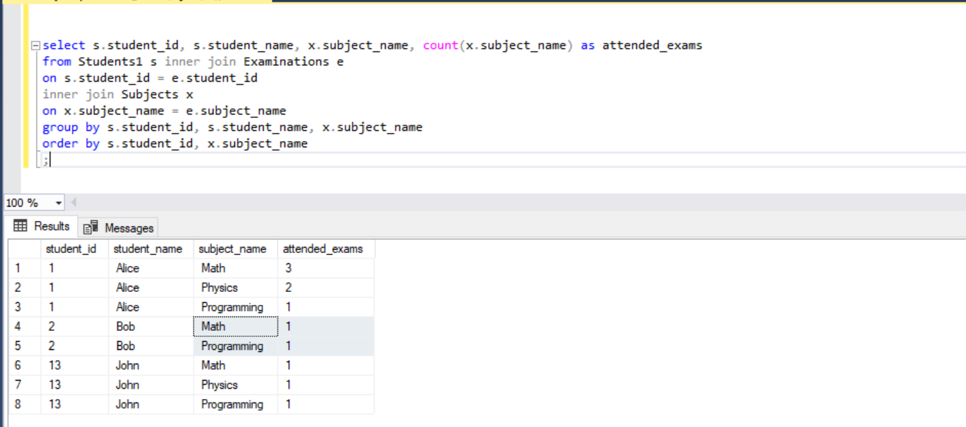

Q71. Write an SQL query to find employee_id of all employees that directly or indirectly report their work to the head of the company. The indirect relation between managers will not exceed three managers as the company is small. Return the result table in any order.

select employee_id from Employees2

where manager_id in

(

select employee_id from Employees2

WHERE manager_id in (

select employee_id from Employees2 where manager_id =1

)

)

and employee_id !=1;

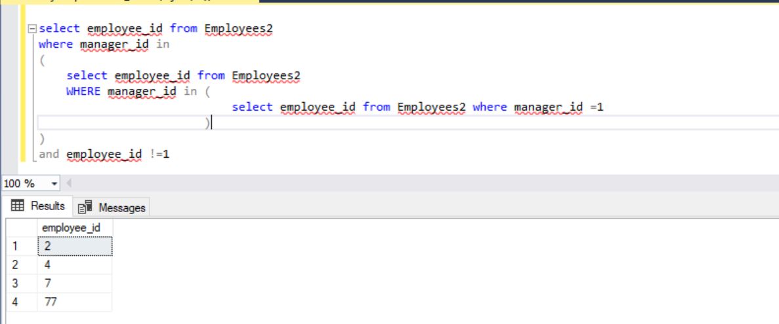

Q72. Write an SQL query to find for each month and country, the number of transactions and their total amount, the number of approved transactions and their total amount. Return the result table in any order.

select month, country, sum(trans_count) trans_count, sum(approved_count) approved_count

, sum(amount) trans_total_amount, sum(approved_total_amo) approved_total_amo

from (select FORMAT(trans_date, 'yyyy-MM') as month, country, amount, state

,count(*) as trans_count

,case when state = 'approved' then 1 else 0 end as approved_count

,SUM(case when state = 'approved' then amount else 0 end) as approved_total_amo

from Transactions

group by FORMAT(trans_date, 'yyyy-MM'), country, amount, state

) tmp

group by month, country

order by 1,2 desc;

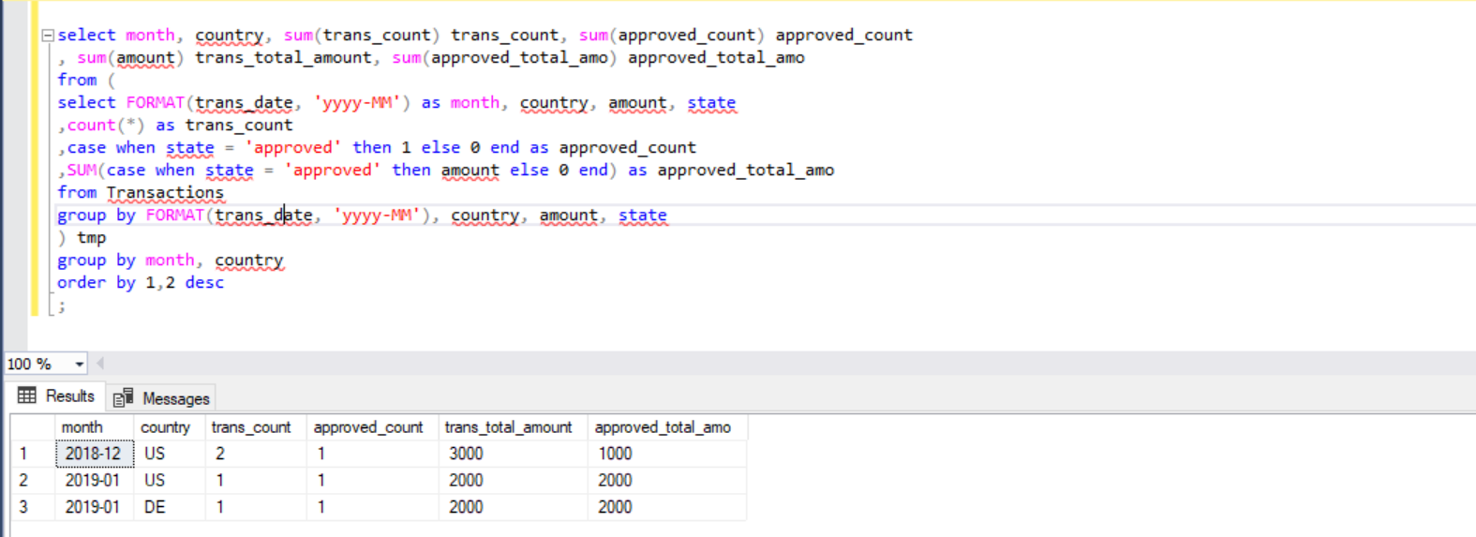

Q73. Write an SQL query to find the average daily percentage of posts that got removed after being reported as spam, rounded to 2 decimal places.

select round(avg(daily_count), 2) as average_daily_percent

from (select count(distinct b.post_id)/count(distinct a.post_id)*100 as daily_count

from actions a

left join removals b

on a.post_id = b.post_id

where extra = 'spam'

group by action_date

) b;

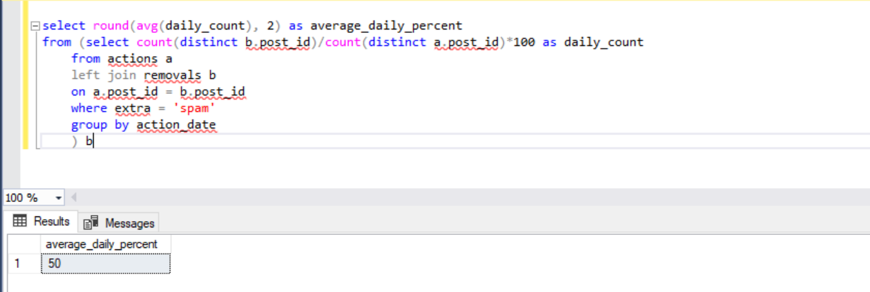

Q76. Write an SQL query to find the salaries of the employees after applying taxes. Round the salary to the nearest integer.

select company_id,employee_id,employee_name,cast((salary - (salary*tax_per)) as int) salary

from (

select *

,case when max_salary < 1000 then 0

when max_salary >= 1000 and max_salary <= 10000 then 0.24

else 0.49

end as tax_per

from

(

select s.*,

max(s.salary) over(partition by s.company_id) as max_salary

from salaries s

) tmp

)tmp2

;

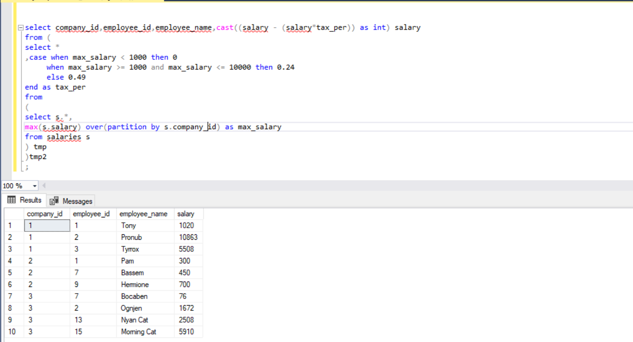

Q78. Write an SQL query to evaluate the boolean expressions in Expressions table. Return the result table in any order.

select left_operand, operator, right_operand

,case when operator = '>' then

case when left_operand > right_operand then 'true' else 'false' end

when operator = '<' then

case when left_operand < right_operand then 'true' else 'false' end

when operator = '=' then

case when left_operand = right_operand then 'true' else 'false' end

end as value

from

(

select *,

case when left_operand = 'x' then (select value from Variables where name='x')

when left_operand = 'y' then (select value from Variables where name='y')

end as left_value

,case

when right_operand = 'x' then (select value from Variables where name='x')

when right_operand = 'y' then (select value from Variables where name='y')

end as right_value

from Expressions e

) tmp;

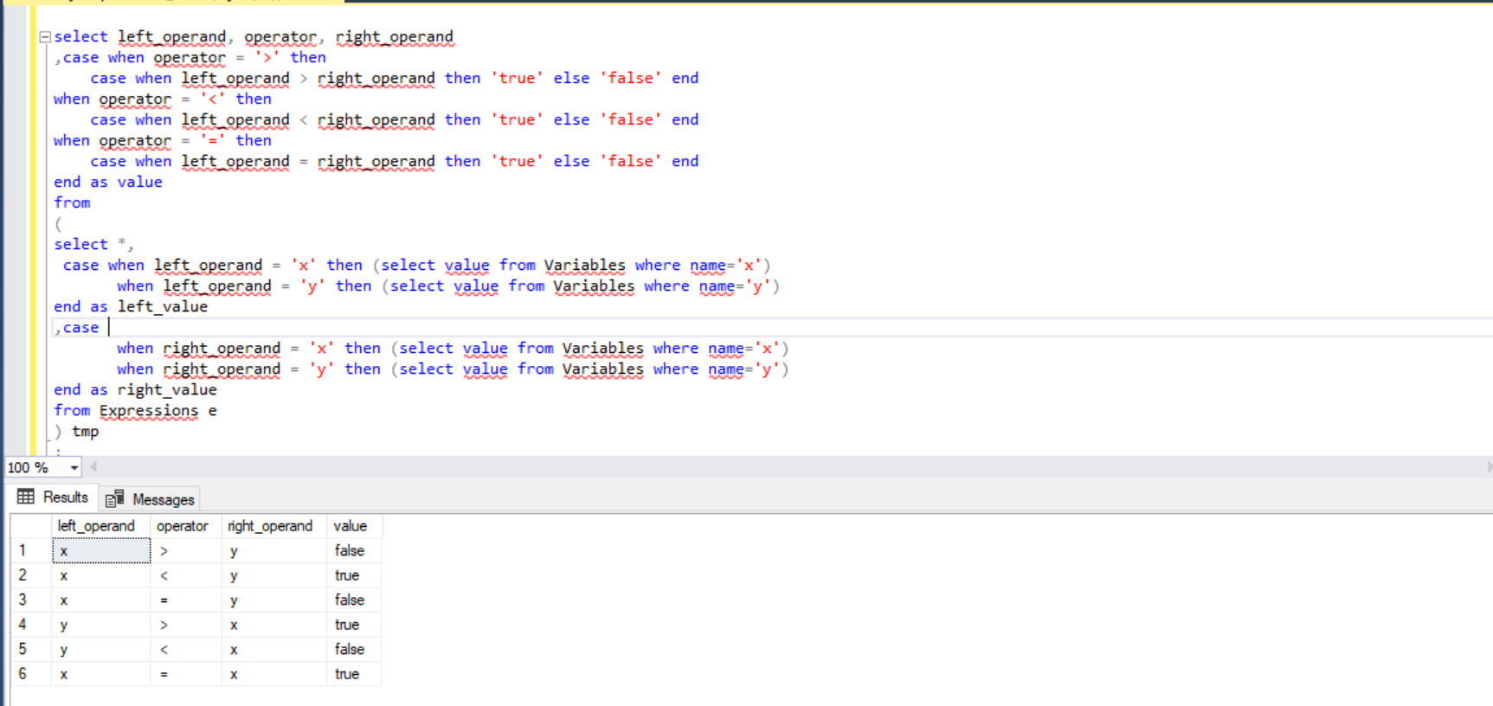

Q81. Query the Name of any student in STUDENTS who scored higher than 75 Marks. Order your output by the last three characters of each name. If two or more students both have names ending in the same last three characters (i.e.: Bobby, Robby, etc.), secondary sort them by ascending ID.

select name

from

(

select *, SUBSTRING(name,len(name)-2,3) as last3

from students2

where marks > 75

) tmp

order by last3, id

;

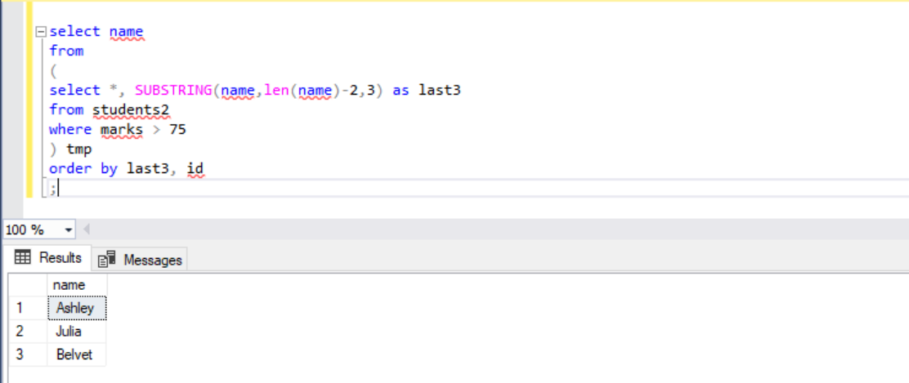

Q82. Write a query that prints a list of employee names (i.e.: the name attribute) from the Employee table in alphabetical order.

select name

from emp2

order by name

;

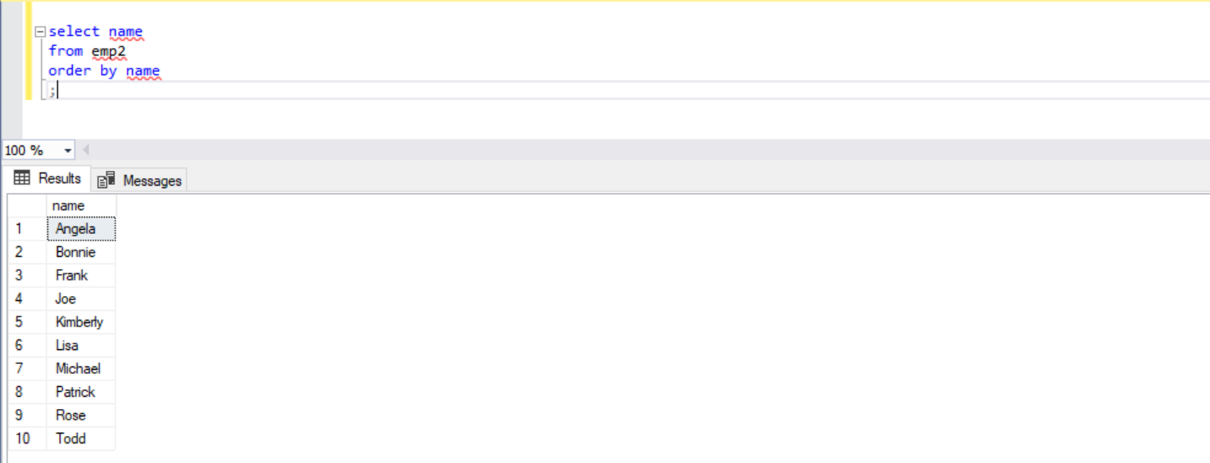

Q83. Write a query that prints a list of employee names (i.e.: the name attribute) for employees in Employee having a salary greater than $2000 per month who have been employees for less than 10 months. Sort your result by ascending employee_id.

select name

from emp2

where salary > 2000 and months < 10

order by employee_id

;

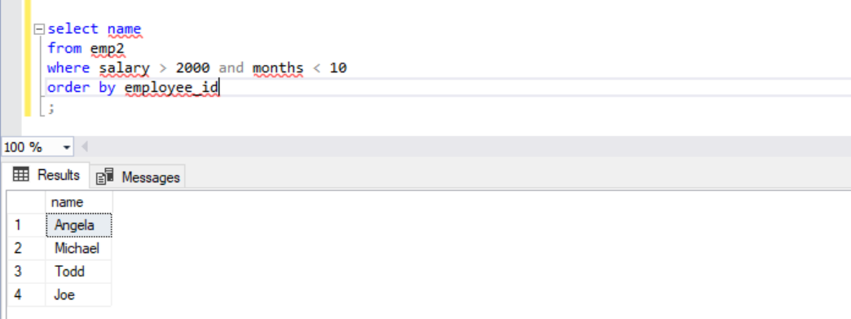

Q84. Write a query identifying the type of each record in the TRIANGLES table using its three side lengths.

select

case when x+y > z and z+y > x and x+z > y

then

case when x=y and y=z and z=x then 'Equilateral'

when x!=y and y!=z and z!=x then 'Scalene'

when x=y then 'Isosceles'

end

else 'Not A Triangle'

end as triangle_type

from Triangle;

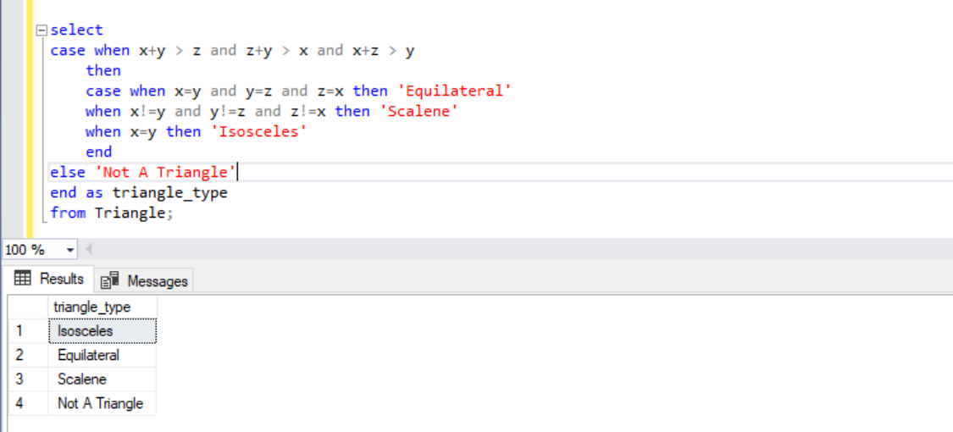

Q85. Write a query to obtain the year-on-year growth rate for the total spend of each product for each year.

select *,

round(((curr_year_spend - prev_year_spend)/prev_year_spend * 100),2) as yoy

from(

select YEAR(transaction_date) as year,

product_id, spend as curr_year_spend,

lag(spend) over(partition by product_id order by transaction_date) as prev_year_spend

from user_transaction

) tmp;

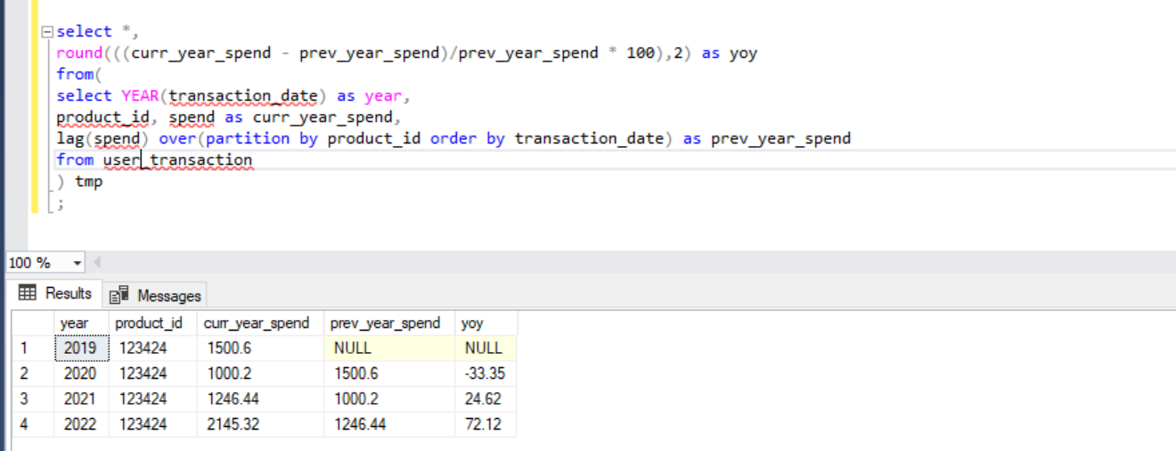

Q86. Write a SQL query to find the number of prime and non-prime items that can be stored in the 500,000 square feet warehouse. Output the item type and number of items to be stocked.

with t1 as (

select *, (item_count*count) sqft

from

(

select *,

cast(((500000/total)) as int) as item_count

from(

select item_type, sum(square_footage) total, count(*) count

from inventory

where item_type = 'prime_eligible'

group by item_type

) tmp

)tmp2

),

t2 as (

select item_type,total, count, cast((sqft/total) as int) as item_count,sqft

from(

select item_type, sum(square_footage) total, count(*) count, 1 as item_count, cast((500000 - (select item_count*total from t1)) as int) sqft

from inventory

where item_type = 'not_prime'

group by item_type

)tmp

)

select item_type, (count * item_count) as item_count

from t1

union all

select item_type, (count * item_count) as item_count

from t2;

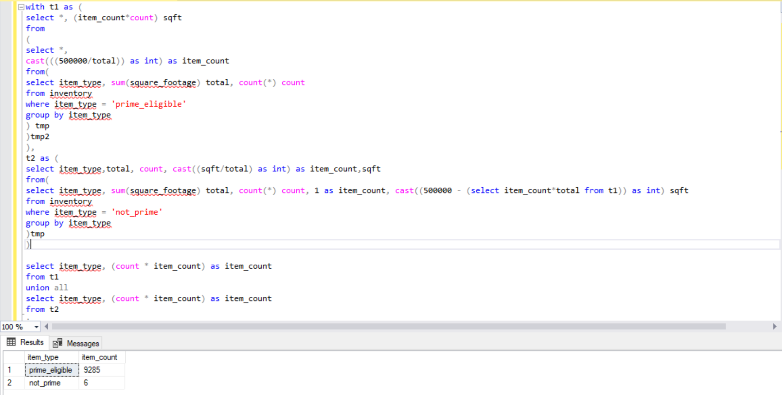

Q87. Write a query to obtain the active user retention in July 2022. Output the month (in numerical format 1, 2, 3) and the number of monthly active users (MAUs).

SELECT

MONTH(curr_month.event_date) AS month,

COUNT(DISTINCT curr_month.user_id) AS monthly_active_users

FROM user_actions AS curr_month

WHERE EXISTS (

SELECT last_month.user_id

FROM user_actions AS last_month

WHERE last_month.user_id = curr_month.user_id

AND MONTH(last_month.event_date) = MONTH(curr_month.event_date) - 1

)

GROUP BY MONTH(curr_month.event_date);

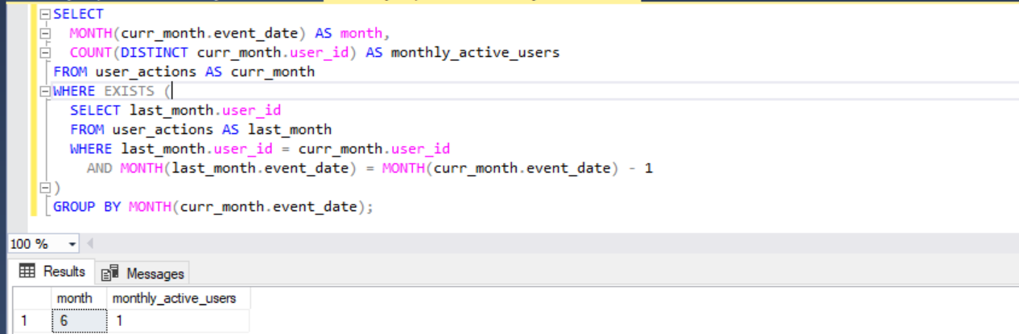

Q88. Write a query to report the median of searches made by a user. Round the median to one decimal point.

select cast(sum(searches) as float)/count(*) as median

from search_frequency;

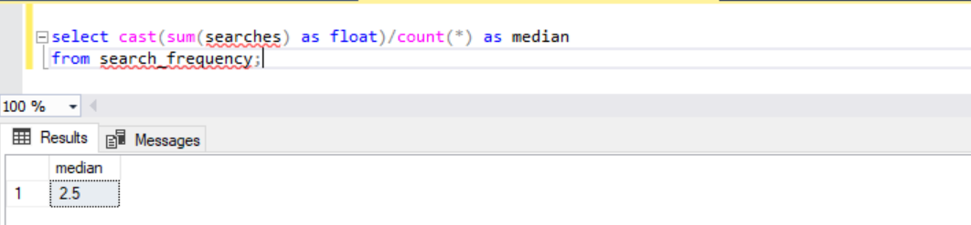

Q89. Write a query to update the Facebook advertiser's status using the daily_pay table. Advertiser is a two-column table containing the user id and their payment status based on the last payment and daily_pay table has current information about their payment. Only advertisers who paid will show up in this table. Output the user id and current payment status sorted by the user id.

WITH payment_status AS (

SELECT

advertiser.user_id,

advertiser.status,

payment.paid

FROM advertiser

LEFT JOIN daily_pay AS payment

ON advertiser.user_id = payment.user_id

UNION

SELECT

payment.user_id,

advertiser.status,

payment.paid

FROM daily_pay AS payment

LEFT JOIN advertiser

ON advertiser.user_id = payment.user_id

)

SELECT

user_id,

CASE WHEN paid IS NULL THEN 'CHURN'

WHEN status != 'CHURN' AND paid IS NOT NULL THEN 'EXISTING'

WHEN status = 'CHURN' AND paid IS NOT NULL THEN 'RESURRECT'

WHEN status IS NULL THEN 'NEW'

END AS new_status

FROM payment_status

ORDER BY user_id;

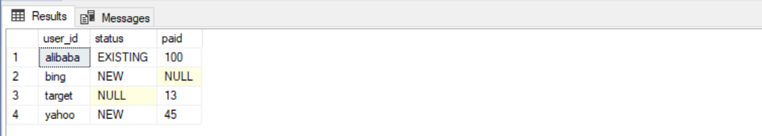

Q90. Write a query that calculates the total time that the fleet of servers was running. The output should be in units of full days.

with cte as(

select server_id,status_time start_time,lead(status_time,1)

over(partition by server_id order by status_time) end_time

from server_utilization

)

select sum(datediff(day,start_time,end_time)) total_uptime_days from cte;

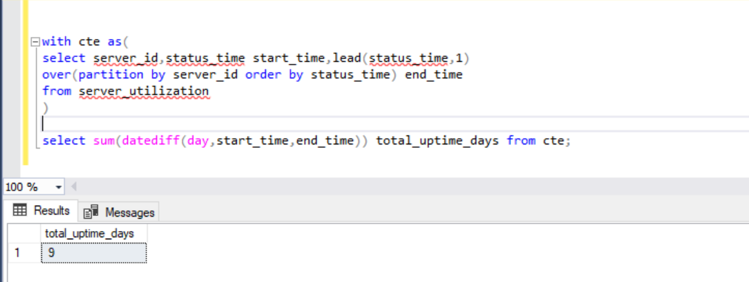

Q91. Sometimes, payment transactions are repeated by accident; it could be due to user error, API failure or a retry error that causes a credit card to be charged twice. Using the transactions table, identify any payments made at the same merchant with the same credit card for the same amount within 10 minutes of each other. Count such repeated payments.

select count(*) as payment_count

from(

select *, DATEDIFF(minute,transaction_timestamp,next_trans_done) as minutes_between

from(

select *,

LEAD(transaction_timestamp,1) over(partition by merchant_id,credit_card_id,amount order by transaction_timestamp) as next_trans_done

from transactions1

)tmp

where DATEDIFF(minute,transaction_timestamp,next_trans_done) < 10

)tmp2

;

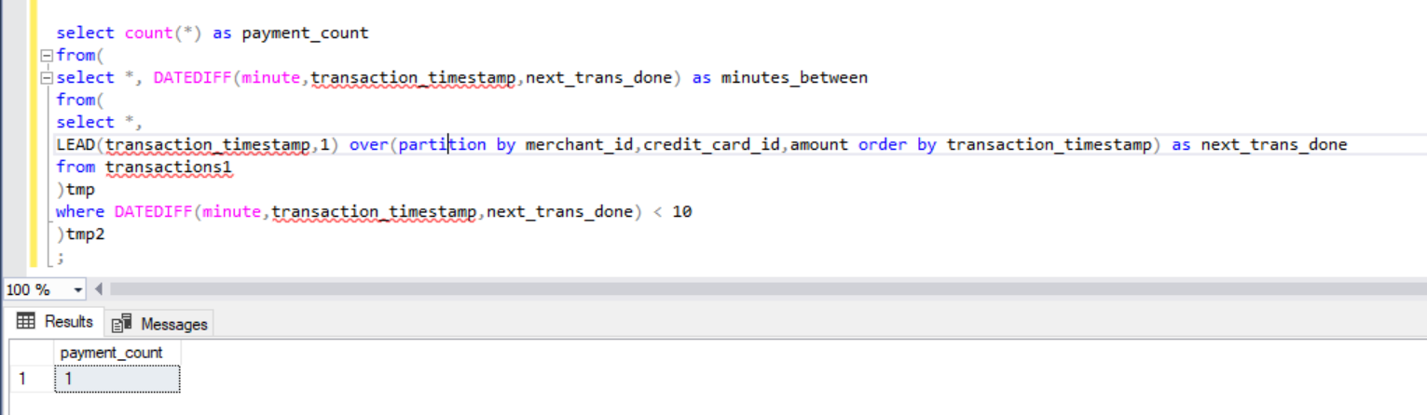

Q92. Write a query to find the bad experience rate in the first 14 days for new users who signed up in June 2022. Output the percentage of bad experience rounded to 2 decimal places.

WITH june22_orders

AS (

SELECT

orders4.order_id,

orders4.trip_id,

orders4.status,

orders4.order_timestamp,

DATEADD(day,14,customers1.signup_timestamp) as ss

FROM customers1

JOIN orders4

ON customers1.customer_id = orders4.customer_id

WHERE MONTH(customers1.signup_timestamp) = 6

AND YEAR(customers1.signup_timestamp) = 2022

and DATEADD(day,14,customers1.signup_timestamp) > orders4.order_timestamp

)

SELECT ROUND (100.0* COUNT (june22.order_id)/(SELECT COUNT (order_id) FROM june22_orders),2) AS bad_experience_pct

FROM june22_orders AS june22

JOIN trips

ON june22.trip_id = trips.trip_id

WHERE june22.status IN ('completed incorrectly', 'never received')

OR trips.actual_delivery_timestamp IS NULL

AND trips.estimated_delivery_timestamp>trips.actual_delivery_timestamp;

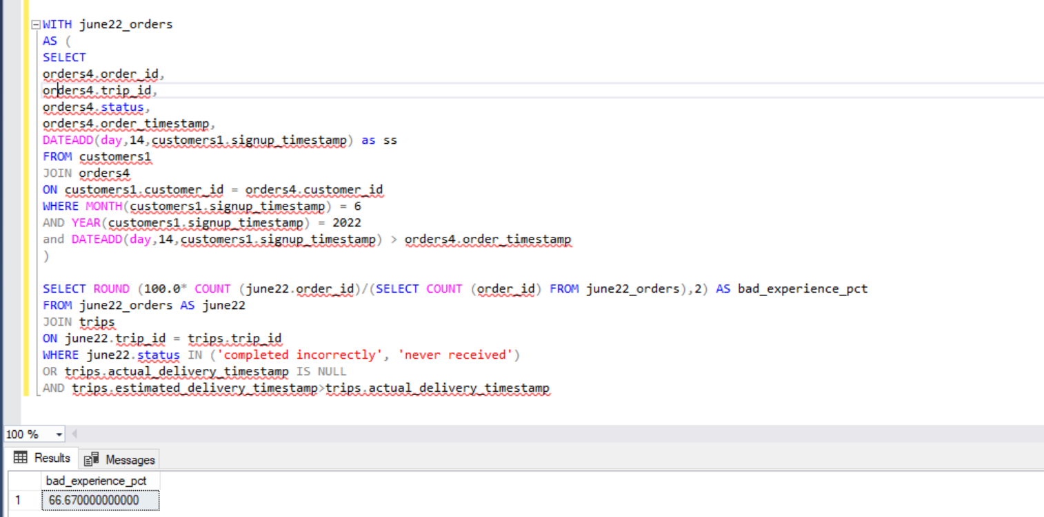

Q95. Write an SQL query to report the median of all the numbers in the database after decompressing the Numbers table. Round the median to one decimal point.

with cte as(

with recursive generate_numbers as

(

select 1 as n

union

select n+1 from generate_numbers where n<(select max(frequency) from Numbers)

)

SELECT num,row_number() over(order by num) rw

FROM Numbers

JOIN generate_numbers

ON Numbers.frequency >= generate_numbers.n

order by num,rw

)

select case

when if(count(*)%2 = 0,'even','odd')='odd'

then (select num from cte where rw = (select count(*)/2 from cte))

when if(count(*)%2 = 0,'even','odd')='even'

then (select round(avg(num),1) from cte where rw in (select floor(avg(rw)) from cte union select ceil(avg(rw)) from cte))

end as median from cte;

Q96. Write an SQL query to report the comparison result (higher/lower/same) of the average salary of employees in a department to the company's average salary.

with cte as (

select e.employee_id,department_id,pay_date,avg(amount)

over (partition by pay_date ) average,

avg(amount)

over (partition by department_id,pay_date )average2

from Salary s

join Employee123 e

on s.employee_id = e.employee_id

)

select pay_date,department_id,case

when average = average2 then 'same'

when average2 > average then 'higher'

when average2 < average then 'lower'

end as comparison

from cte

;

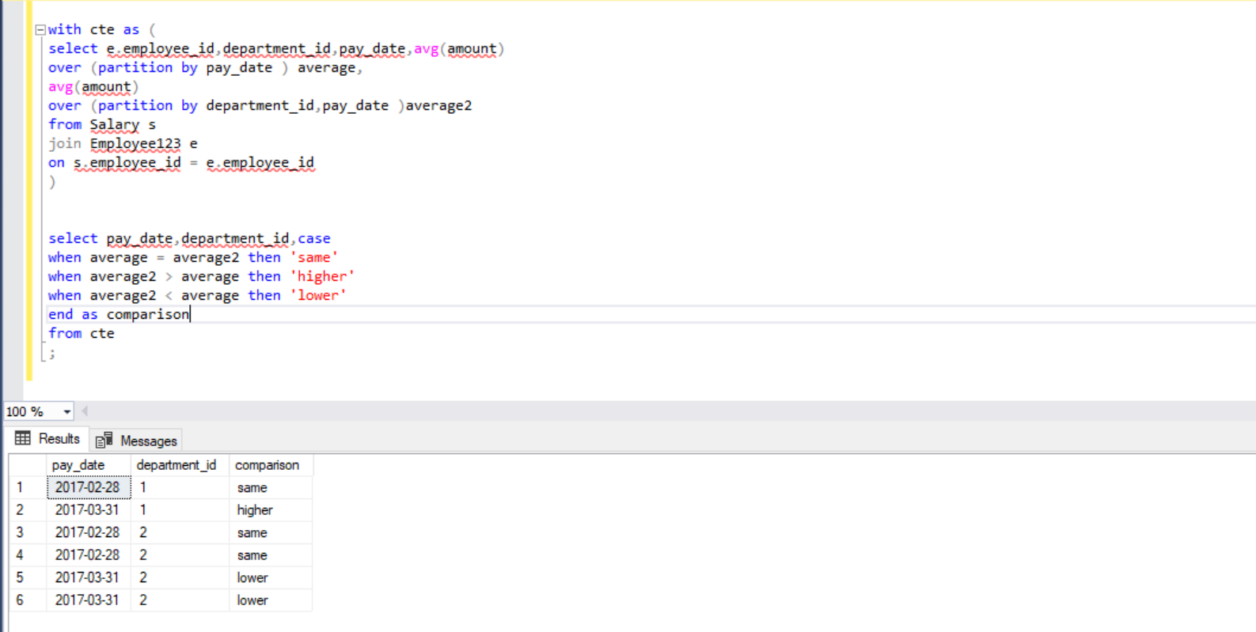

Q97. Write an SQL query to report for each install date, the number of players that installed the game on that day, and the day one retention.

with cte as

(select player_id,

count(player_id) over (partition by event_date order by event_date ) ct,

min(event_date) over (partition by player_id order by player_id ) dt,

event_date,

lead(event_date,1) over(partition by player_id order by player_id) next_date from Activity

),

cte2 as(select

distinct dt install_dt, max(ct) installs

from cte group by dt),

cte3 as (select count(*) cnt,event_date from cte where

DATEDIFF(day,event_date,next_date) =1 group by event_date)

select install_dt,installs,isnull(round(cnt/cast(installs as decimal(10,2)),1),0)

Day1_retention from cte2 left join cte3 on cte2.install_dt = cte3.event_date;

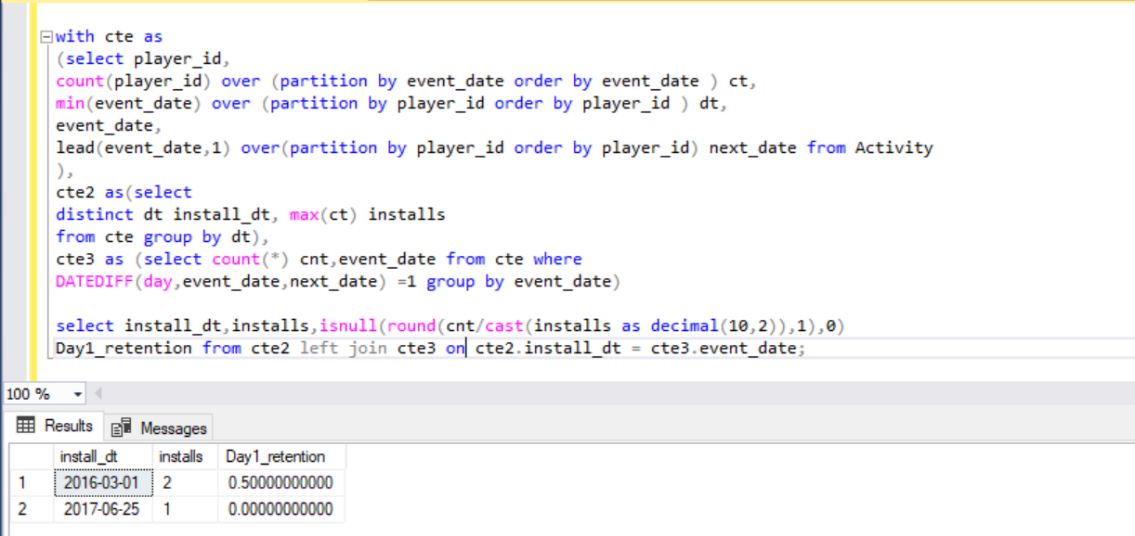

Q98. Write an SQL query to find the winner in each group. Return the result table in any order.

with cte as (

select match_id,first_player as player_id, first_score as score from Matches1

union all

select match_id,second_player as player_id, second_score as score from Matches1

), cte2 as (

select group_id, p.player_id, score,

sum(score) over (partition by p.player_id) as total

from cte c inner join Players p

on c.player_id = p.player_id

), cte3 as (

select distinct group_id,player_id,

dense_rank() over(partition by group_id order by total desc,player_id) as rnk

from cte2

)

select group_id,player_id

from cte3

where rnk = 1

;

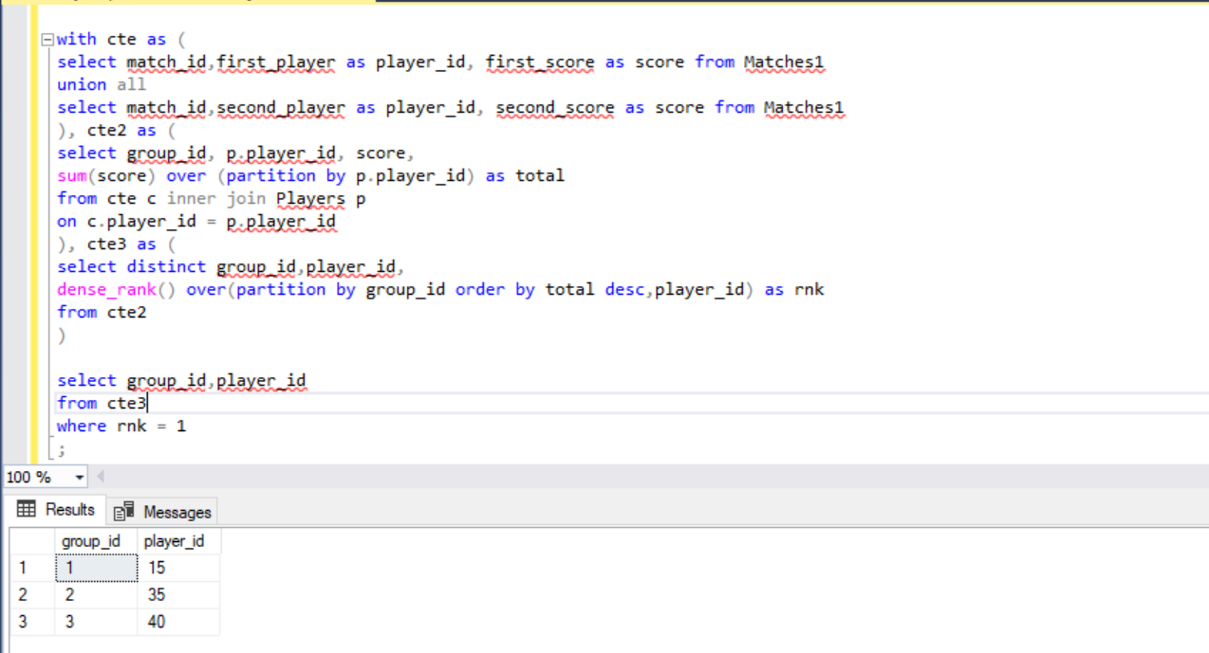

Q99. Write an SQL query to report the students (student_id, student_name) being quiet in all exams. Do not return the student who has never taken any exam.

with cte as

(

select e.exam_id,s.student_id, s.student_name, e.score

,min(score) over(partition by e.exam_id) as min_score

,max(score) over(partition by e.exam_id) as max_score

from Student5 s inner join Exam5 e

on s.student_id = e.student_id

),

cte2 as (

select *

,min(student_id) over(partition by exam_id order by score) as min_stu

,max(student_id) over(partition by exam_id order by score desc) as max_stu

from cte

)

select distinct student_id, student_name

from cte2

where score > min_score and score < max_score

and student_id not in (select distinct min_stu from cte2)

and student_id not in (select distinct max_stu from cte2)

;

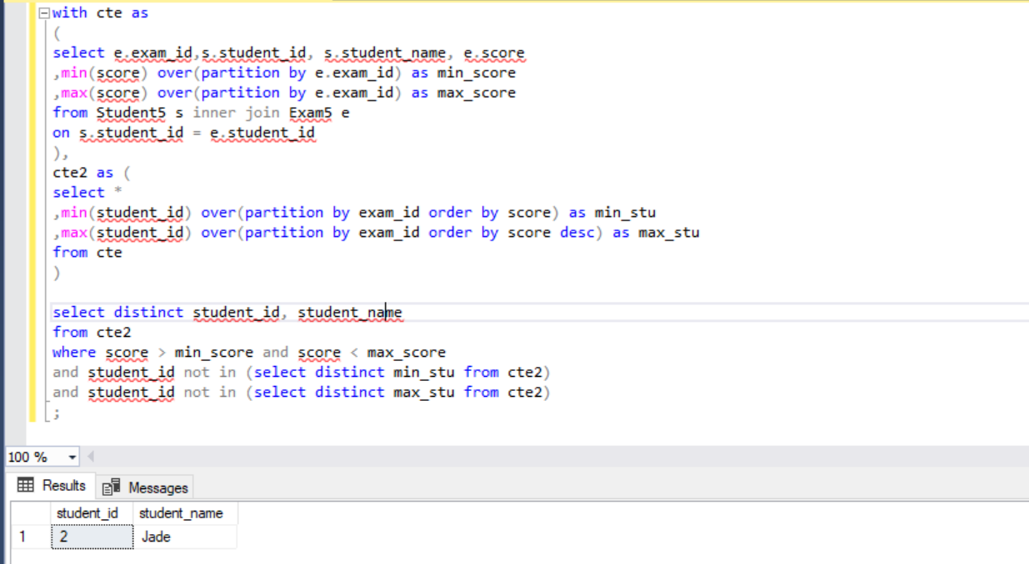

Q 101. Write an SQL query to show the second most recent activity of each user. If the user only has one activity, return that one. A user cannot perform more than one activity at the same time. Return the result table in any order.

select username,activity,startDate,endDate

from(

select *,count(*) over(partition by username) as cnt,

DENSE_RANK() over(partition by username order by startDate) as rnk

from UserActivity

)tmp

where rnk = 1

;

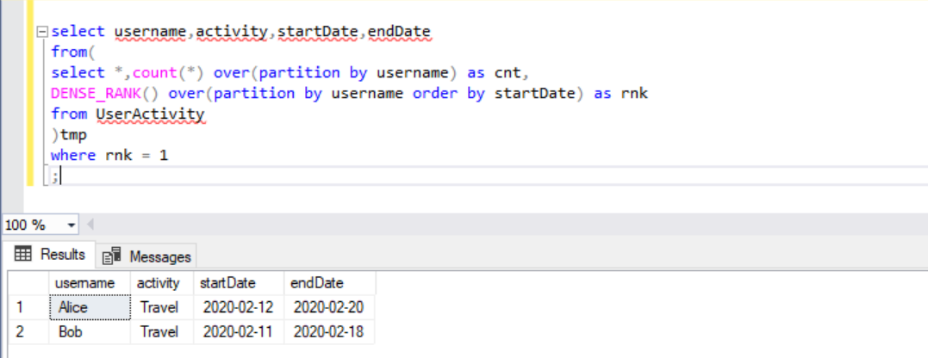

Q107. Write a query calculating the amount of error (i.e.: actual - miscalculated average monthly salaries), and round it up to the next integer.

select avg(salary) - avg(cast(replace(cast(salary as varchar),'0','') as int)) as dd

from emp3

;

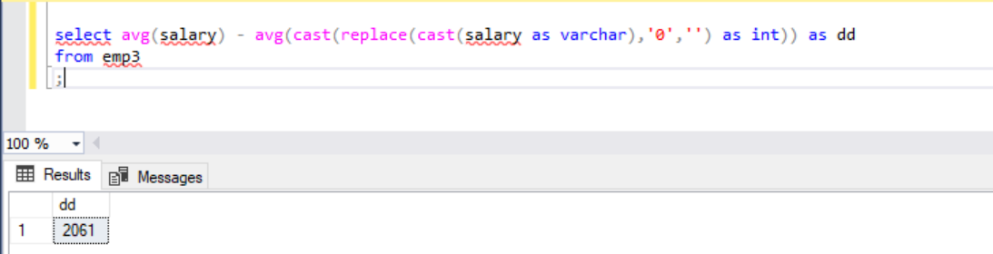

Q108. Write a query to find the maximum total earnings for all employees as well as the total number of employees who have maximum total earnings. Then print these values as 2 space-separated integers.

with cte as(

select *, (months*salary) as earnings

from emp4

)

select max(earnings) as earning,

count(*) as count

from cte where earnings = (select max(earnings) from cte)

;

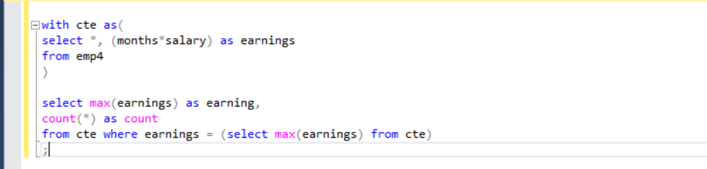

Q109. 1. Query an alphabetically ordered list of all names in OCCUPATIONS, immediately followed by the first letter of each profession as a parenthetical (i.e.: enclosed in parentheses). For example: AnActorName(A), ADoctorName(D), AProfessorName(P), and ASingerName(S). Query the number of occurrences of each occupation in OCCUPATIONS. Sort the occurrences in ascending order, and output them in the following format.

select occ

from(

select name+'('+SUBSTRING(occupation,1,1)+')' as occ

from occupation

) tmp

union all

select 'There are a total of '+cast(count as varchar)+' '+occ as occ

from(

select LOWER(occupation)+'s' occ,count(*) as count

from occupation

group by occupation

)tmp

order by occ

;

